**Jenkins Notes**

1. Make Jenkins Public DNS **[Step 2 in Ajay Sir Notes]**

echo "public ip_address" "jenkins_local" >> /etc/hosts



Cat /etc/hosts

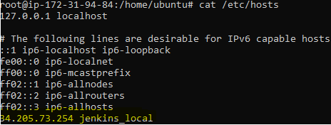

1. Dashboard **[Step 3 in Ajay Sir Notes]**

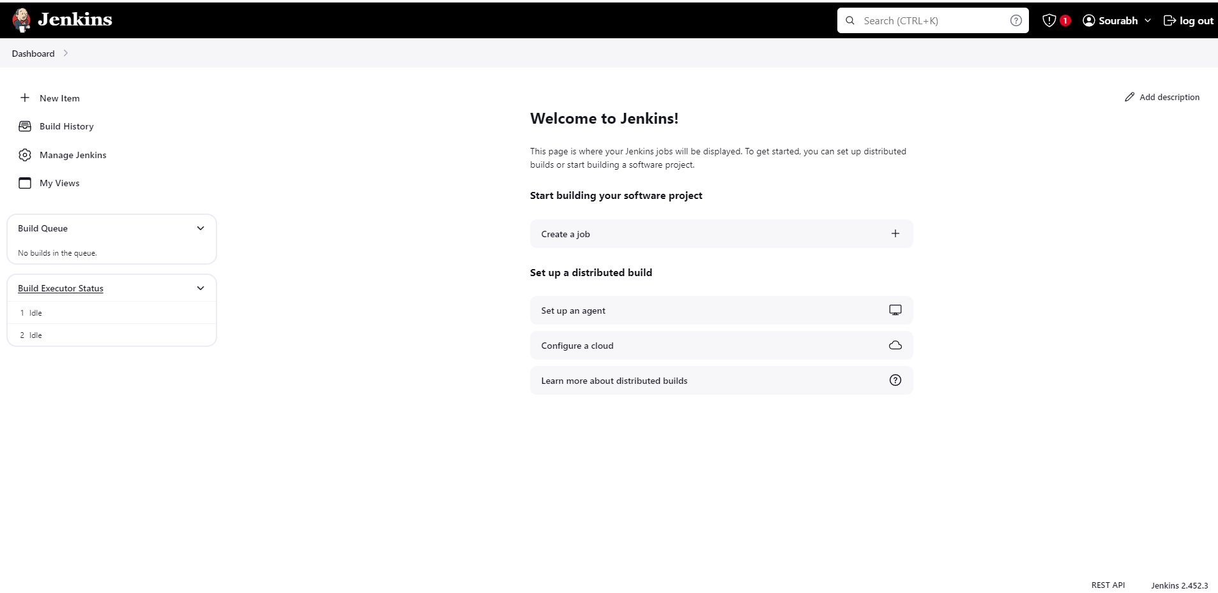

1. Create first Jenkins job **[Step 4 in Ajay Sir Notes]**

Click on New Item

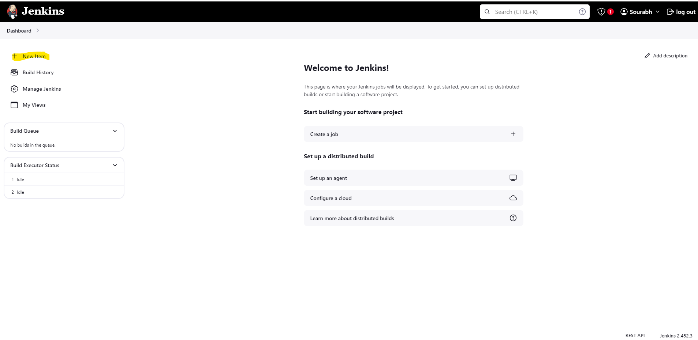

There are multiple types of jobs and their details are mentioned along with the jobs

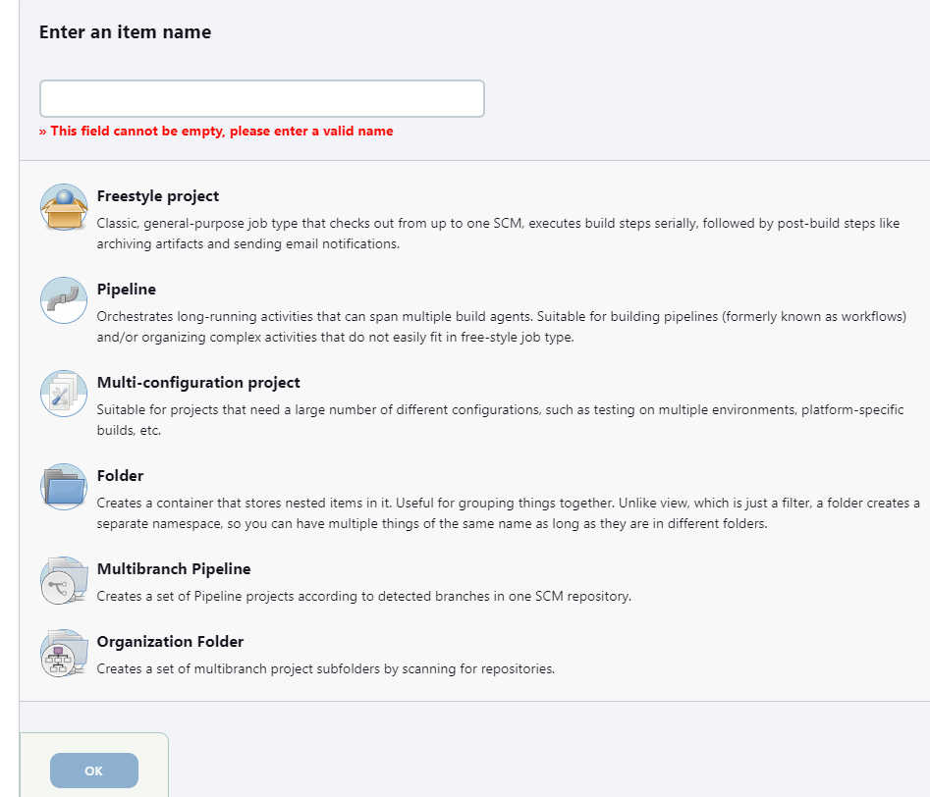

Enter the item name and select Freestyle project and hit OK

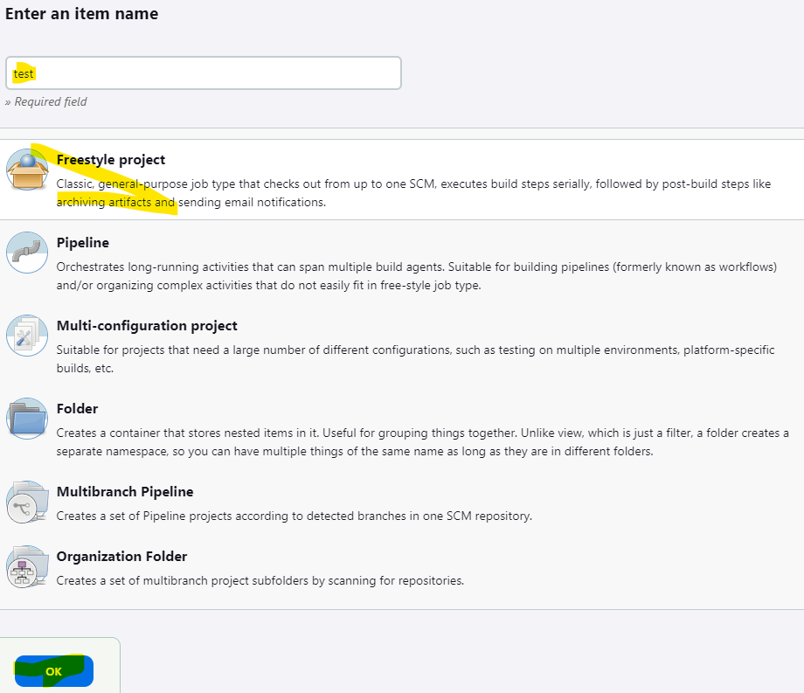

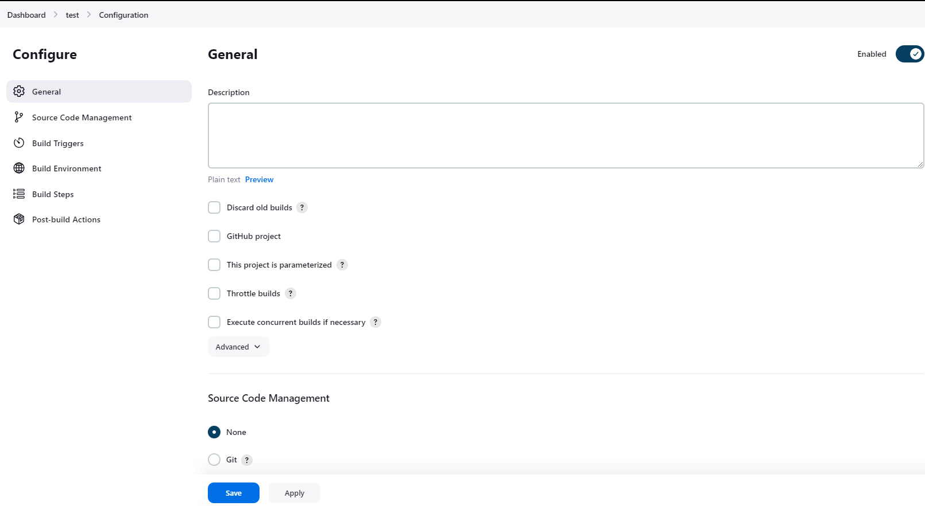

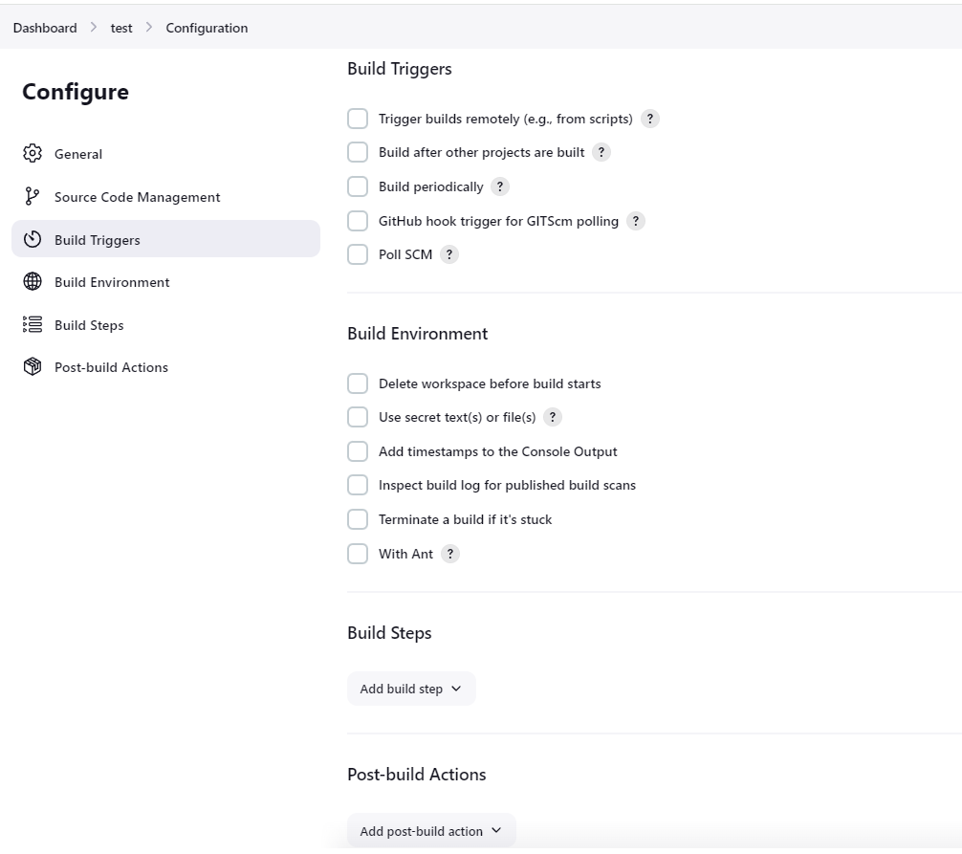

Add build Steps and select Execute Shell, Write the commands and click save

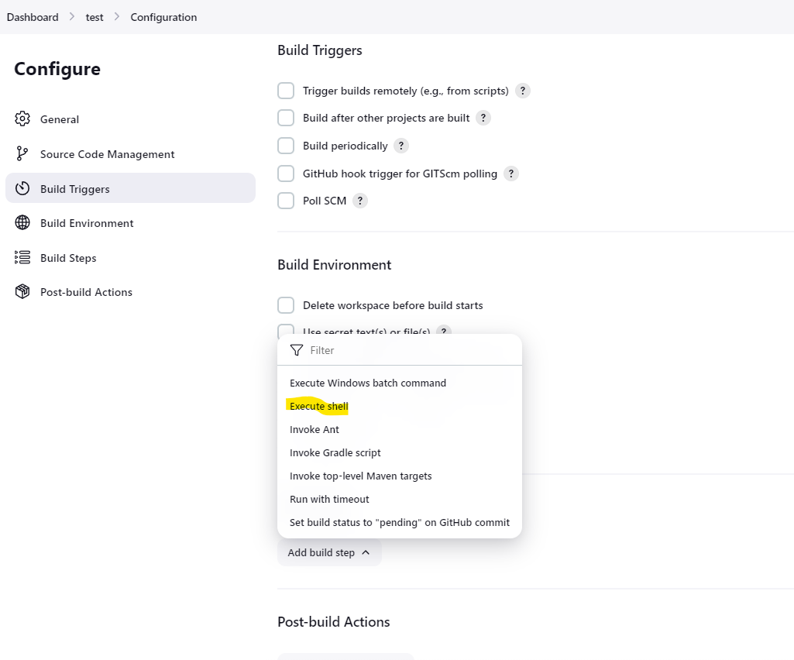

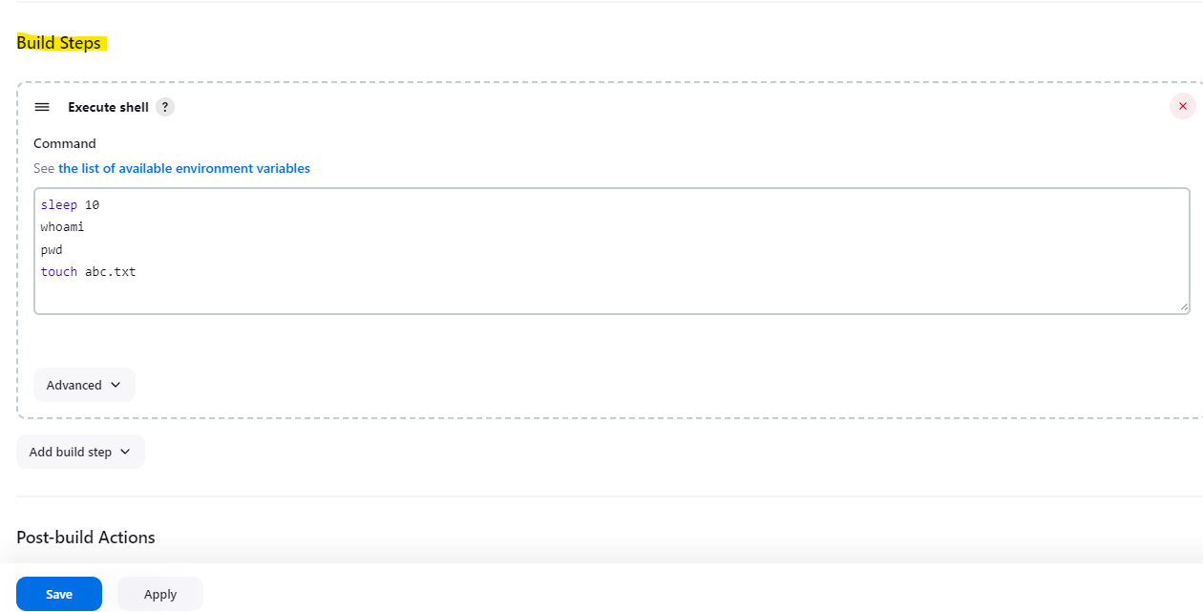

Click on build now to the Job

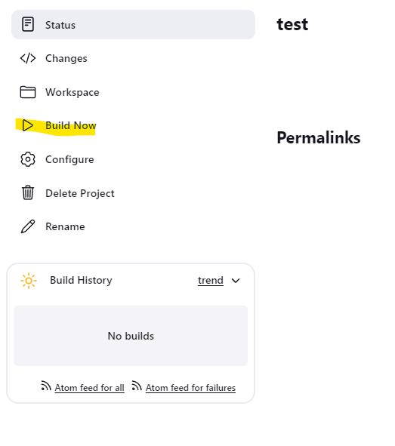

Build history will show you the Jobs that ran and are running

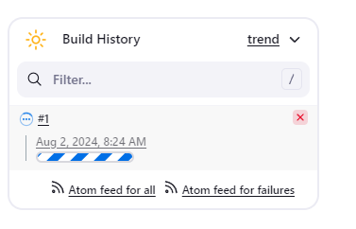

Below screenshot shows job completed successfully

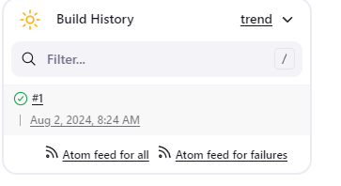

Click on the number on the above screenshot to show job details and console output to show the output of the job

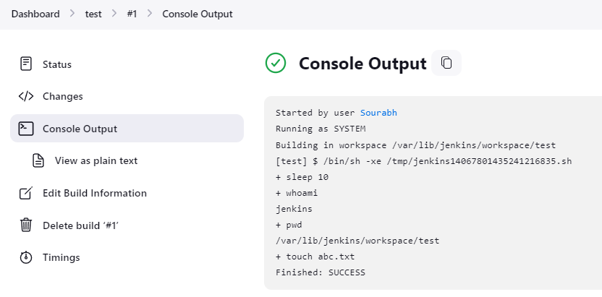

/var/lib/Jenkins/workspace/test – Job Location where it executes build.

1. Meaning of different Weather signs for a project/Item on the dashboard

* Sunshine – Job Success so far with no failures



* Cloud – Job Failed once, shows time in last failure and also tells the build number on which it failed. 
* Shower – Job failed twice, shows time in last failure and also tells the build number on which it failed.



* Rain - Job failed thrice, shows time in last failure and also tells the build number on which it failed.



* Thunderstorm – Job failed fourth time, shows time in last failure and also tells the build number on which it failed.



* Partly Cloudy – Status success after multiple fails, change in Last Success



This is maximum time the weather icon changes and once the build starts succeeding, icon changes back to Sunshine after multiple success.

1. If we want to remove old builds and keep only specific number of builds.

Click configure on the job and check discard old builds and give the Max # of builds to keep mentioned in the screenshot and click save

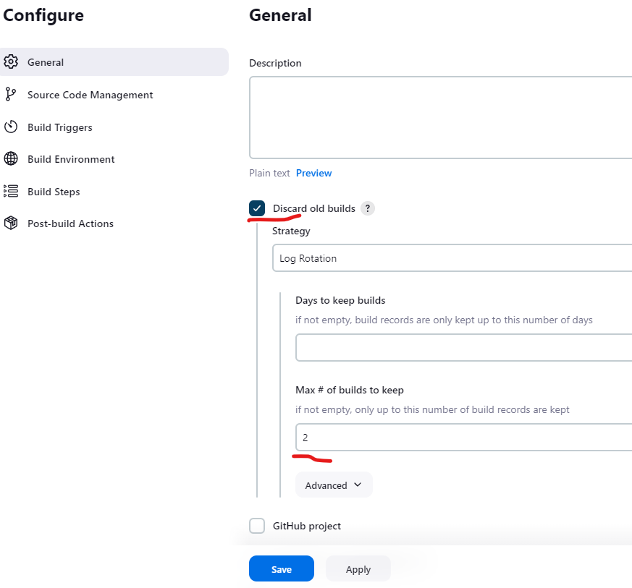

Click Build Now

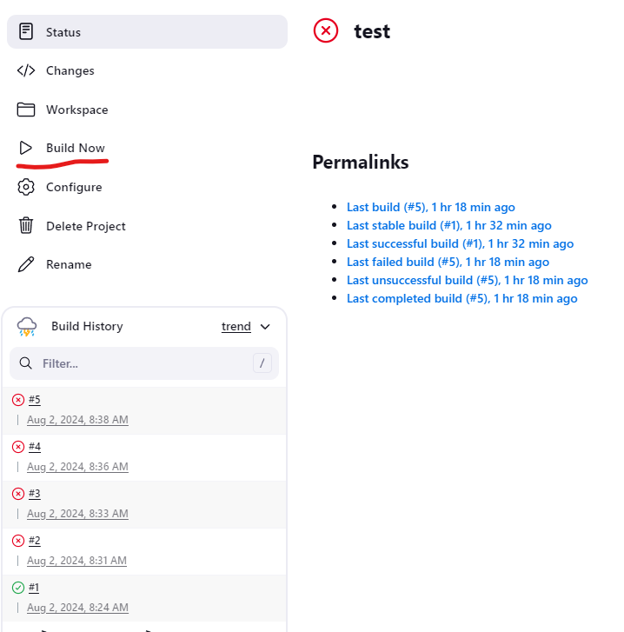

Once the build is completed, see only last 2 builds are left rest are deleted. See screenshot below

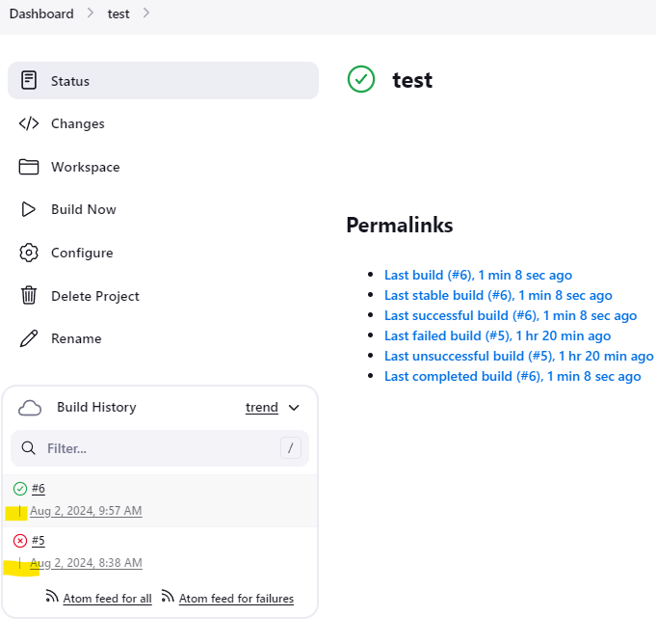

1. Now if we want to delete the content of the workspace, Click configure on the job. Under Build Environment, Check the option Delete workspace before build starts and hit save.

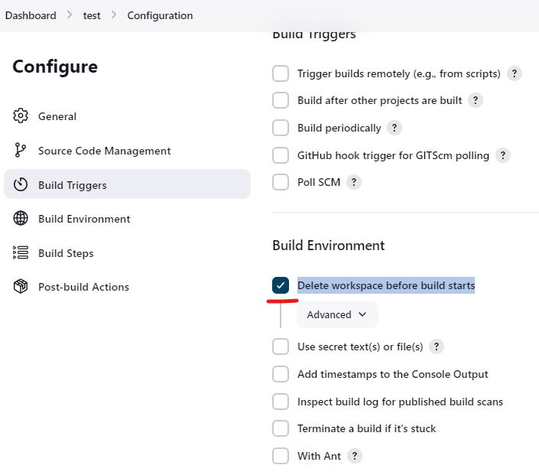

Click Build Now



See all the contents are deleted under workspace of job test

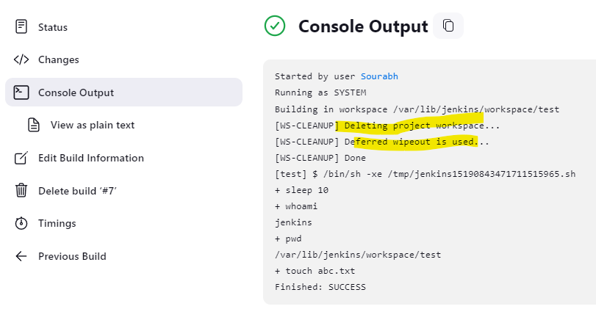

1. Create a new job and copy the contents from old eg test to test1

Click on New item



Enter the item name (test1) and select Freestyle project and scroll down to copy from and enter the job name where you want to copy contents from eg in our case copy contents from test and click ok

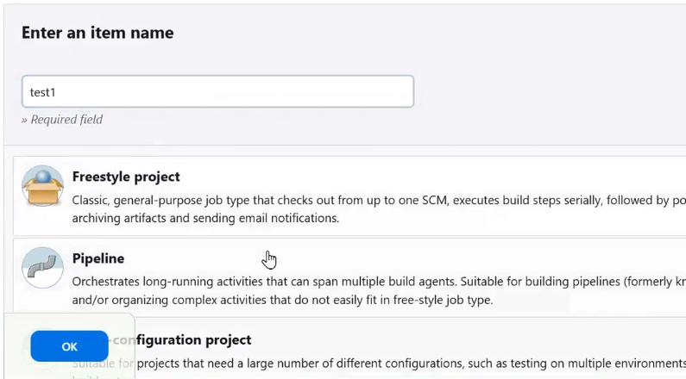

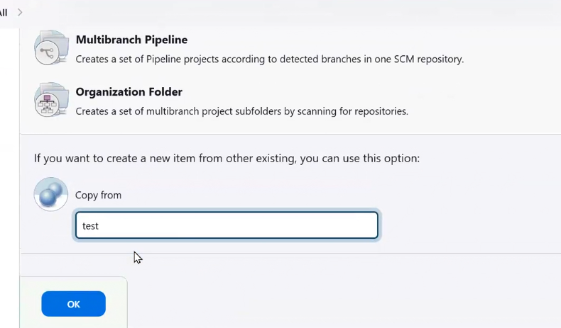

All contents are copied from test

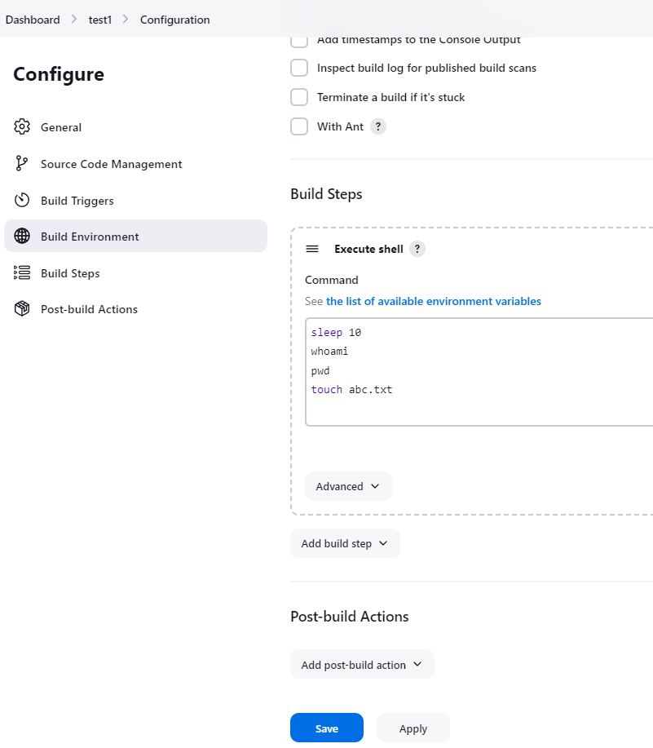

1. Defining second job to be triggered if the first job succeeds (Downstream) **[Step 12 in Ajay Sir Notes]**

Click configure on the job. Go to post build actions and select build from other projects

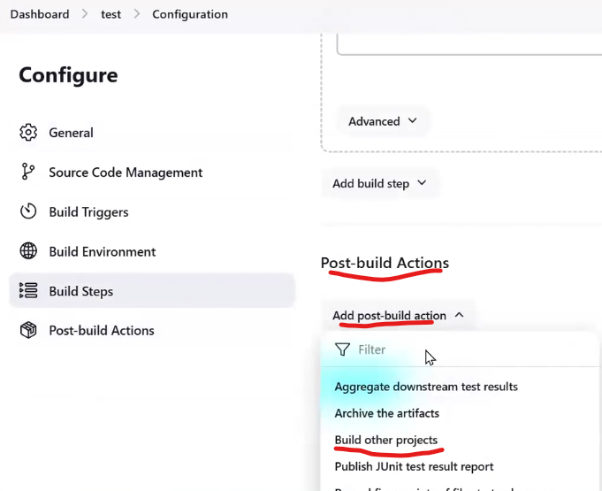

Then under Build other projects. Type the second project i.e. test1 and keep trigger only if build is stable. and click save.

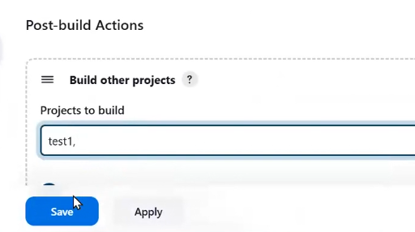

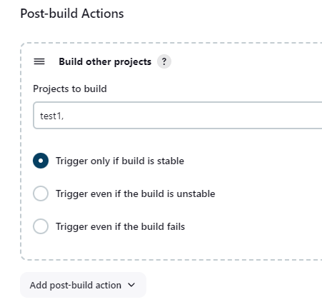

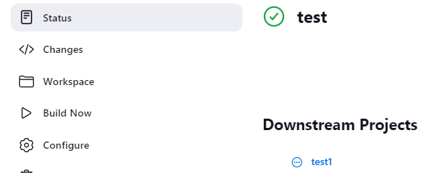

After Build now, both jobs are success in below screenshot

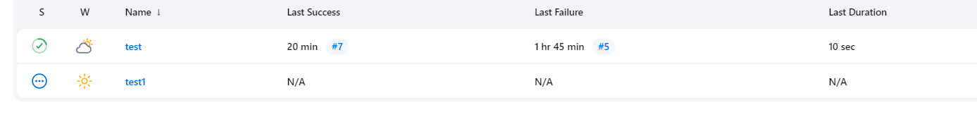

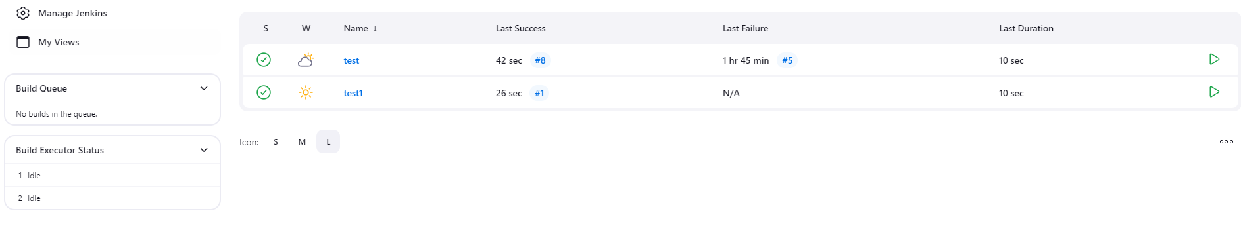

NOTE: There are two other conditions for build another project

* Trigger even if the build is unstable – If this condition is selected, then the second project is executed even if there are some warnings or errors in the upstream job/project
* Trigger even if the build fails. – If this condition is selected, then the second project is executed even if the upstream job/project fails completely.

1. Search panel **[Step 5 in Ajay Sir Notes]**

Type Job name – It will redirect you to the job. See in screenshot

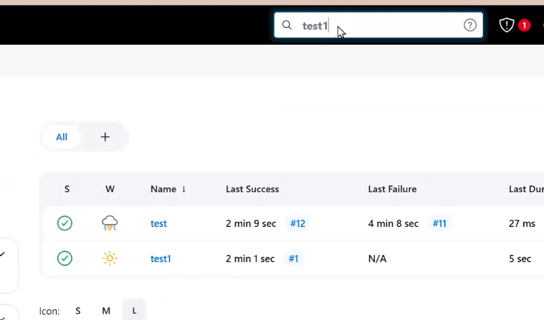

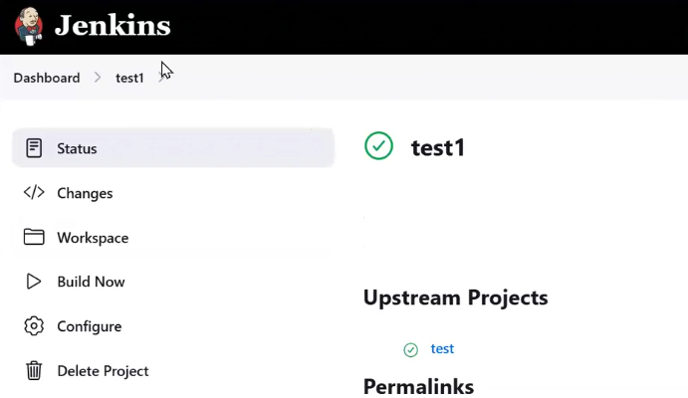

To go to build- Type job name # Build number in search panel

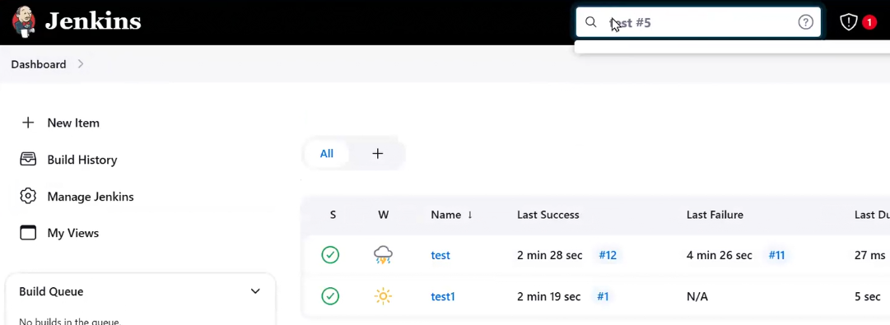

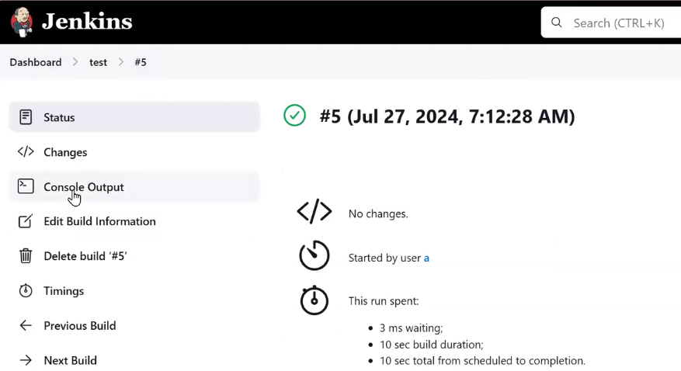

1. System Configuration overview. **[Step 6 in Ajay Sir Notes]**

Manage Jenkins- For admin tasks

System- To change any configuration of plugins which you have installed

Home directory path

System Message

Jenkins URL

No. of executor- no of job execution together

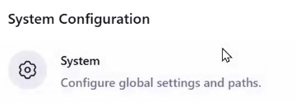

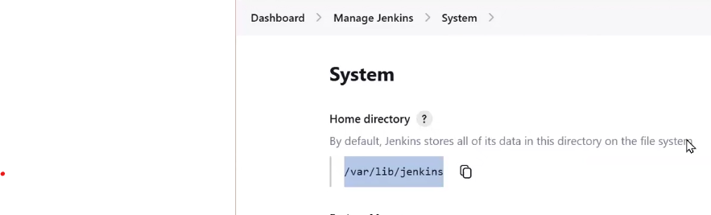

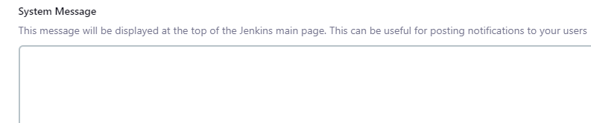

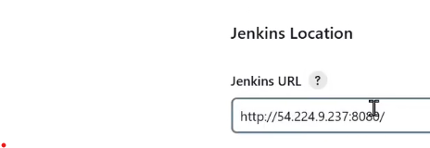

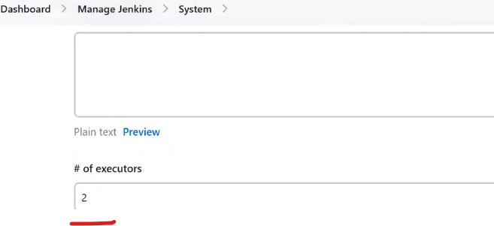

Tools - to install any tool

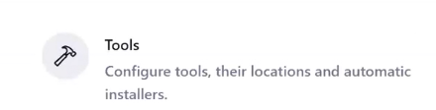

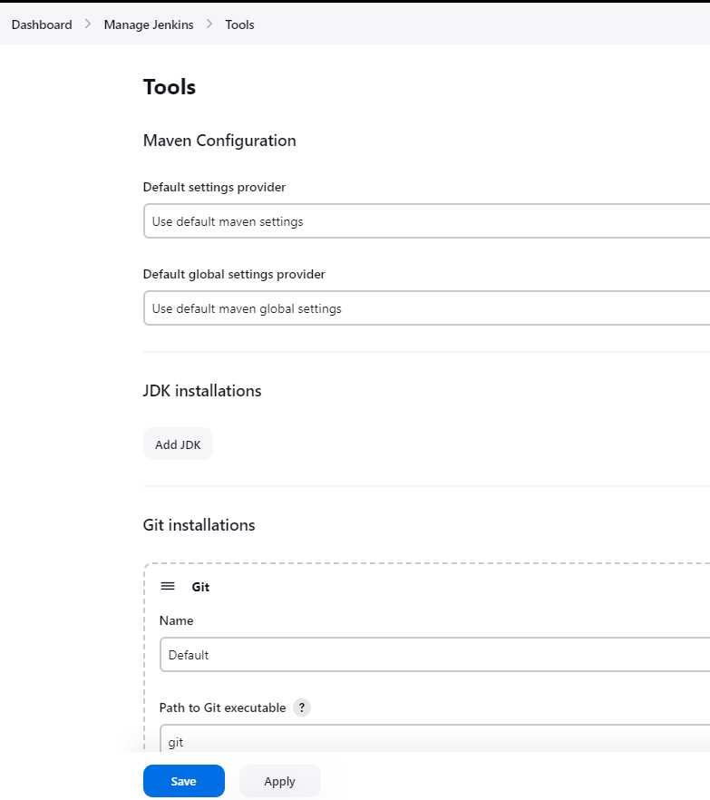

Manage plugins

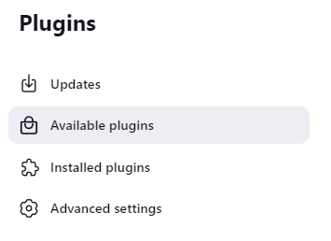

Nodes

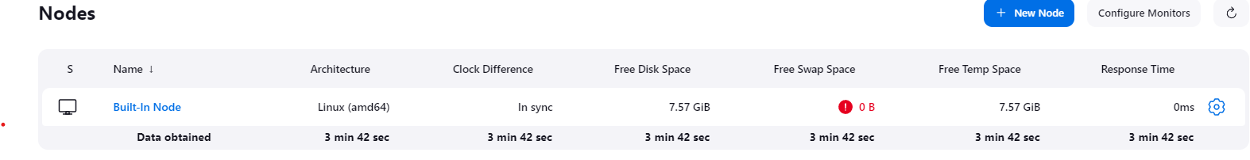

Security

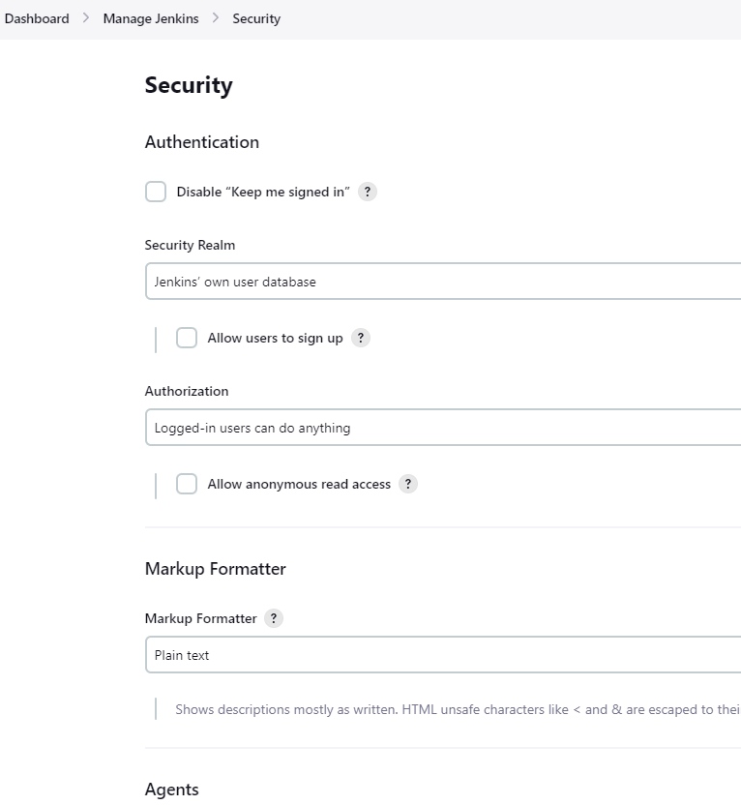

Credentials

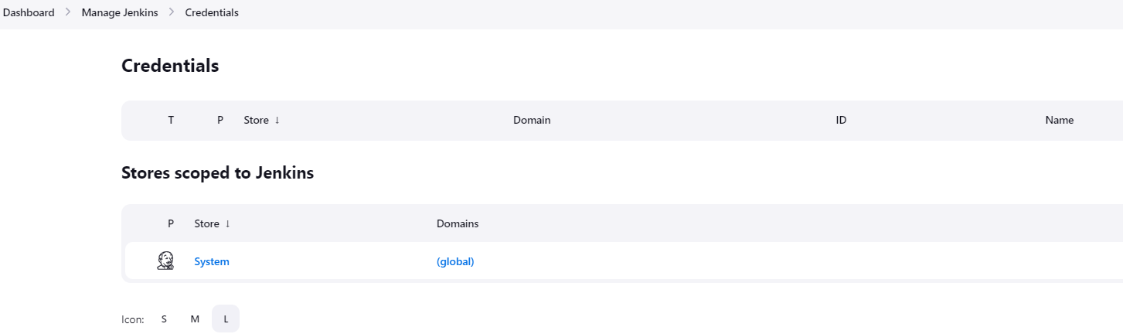

Users

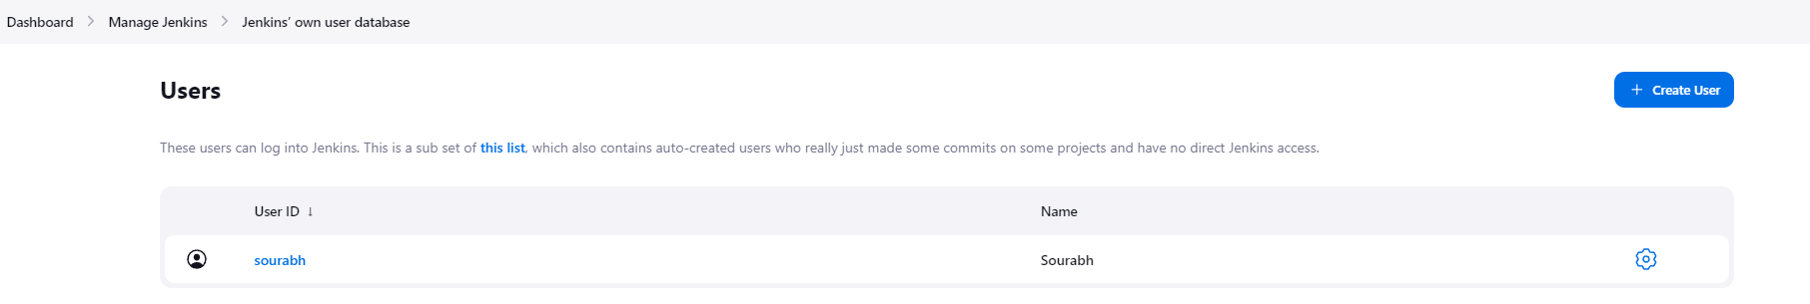  
11) How to change Jenkins Theme **[Step 7 in Ajay Sir Notes]**

Goto to the link <https://github.com/afonsof/jenkins-material-theme>

**Follow the steps GitHub page**

* Choose your color: [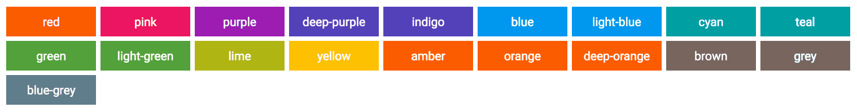](https://camo.githubusercontent.com/7bd878aed9635e503fbf9a3637d8347bad5d29b90cb8ecf75d214d90acaa92d4/687474703a2f2f61666f6e736f662e636f6d2f6a656e6b696e732d6d6174657269616c2d7468656d652f696d616765732f70616c6c6574652e706e67)
* Replace {{your-color-name}} in the URL by the chosen color: <https://cdn.rawgit.com/afonsof/jenkins-material-theme/gh-pages/dist/material-purple.css>
* Install [Jenkins Simple Theme Plugin](https://wiki.jenkins-ci.org/display/JENKINS/Simple+Theme+Plugin) by going to Manage Jenkins>Plugins> Available Plugins>Simple Theme and select Install

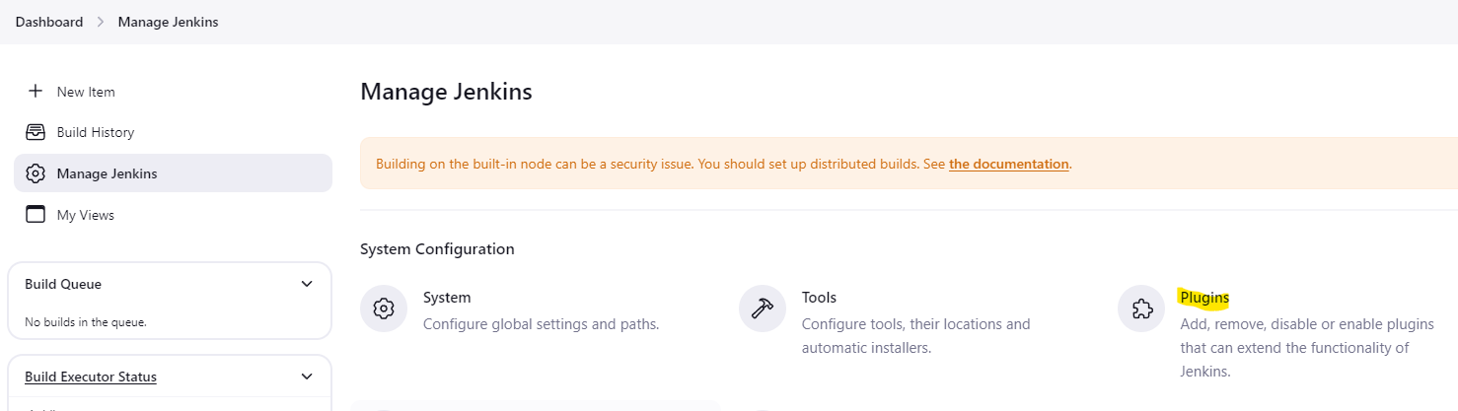

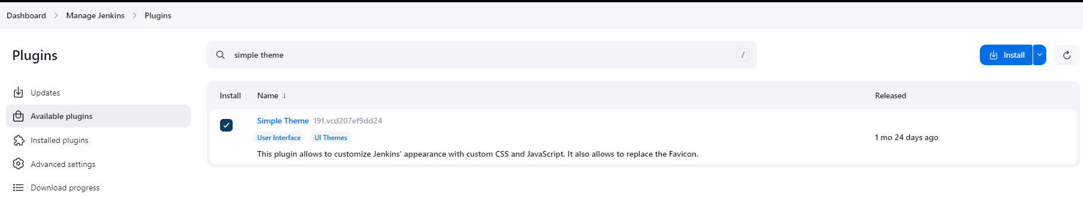

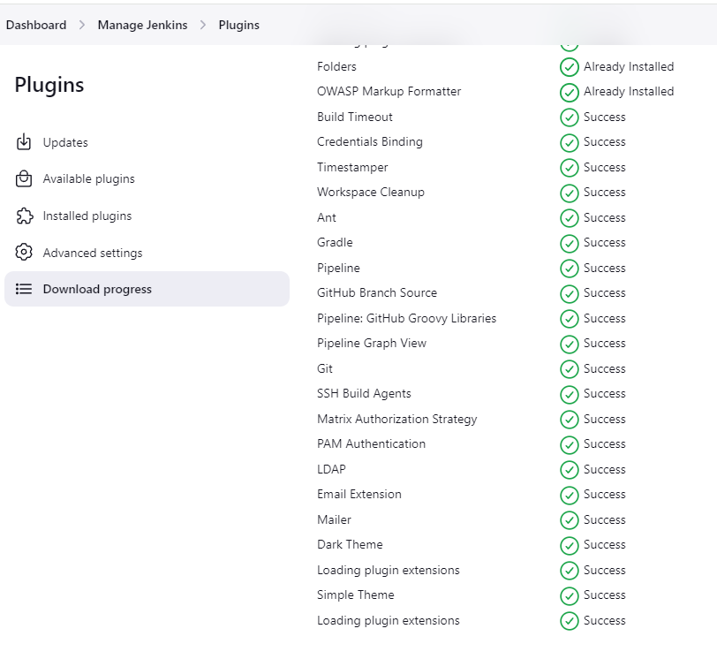

* Click Manage Jenkins > Appearance

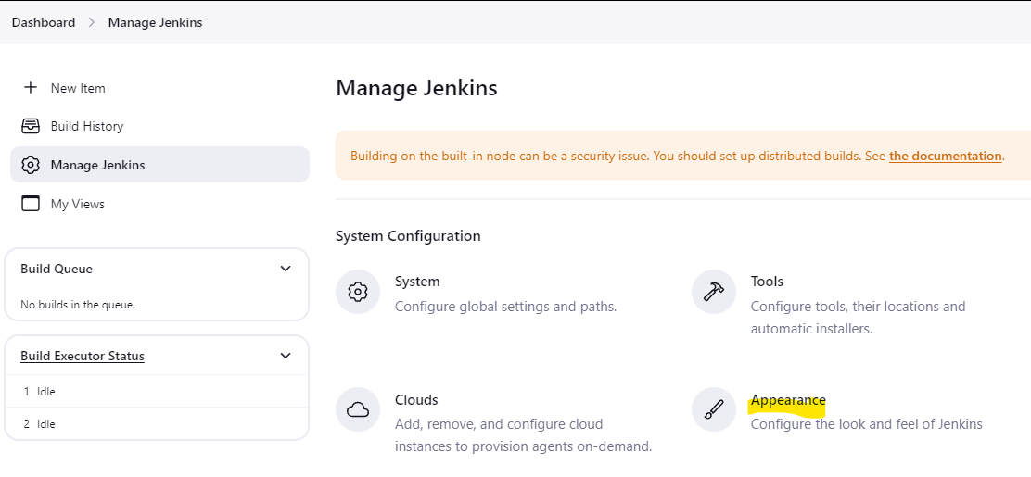

* Scroll down and under Customizable theme>Theme Elements>Drop Down on Add and select CSS URL

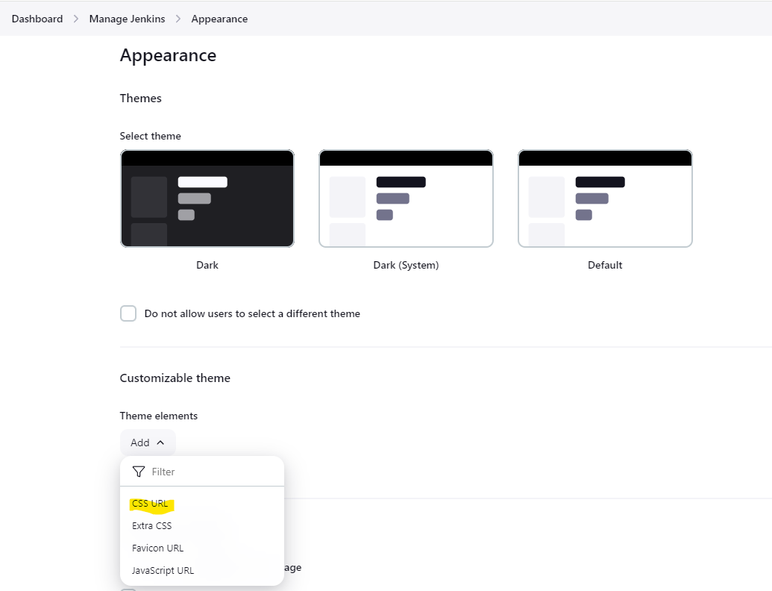

* Set the CSS URL field to the below generated URL and click Save.

<https://cdn.rawgit.com/afonsof/jenkins-material-theme/gh-pages/dist/material-purple.css>

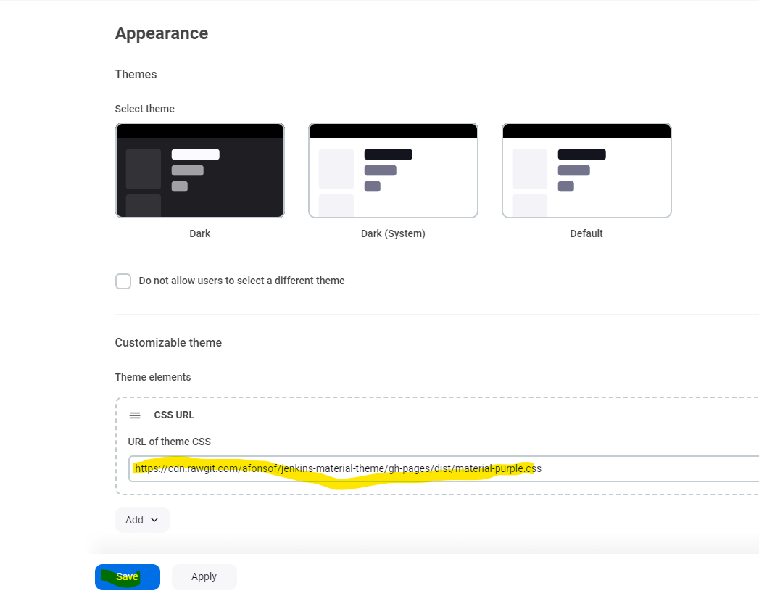

* Once we save and go back to the dashboard, we see the changes are applied.



12) How to create a User in Jenkins. **[Step 8 in Ajay Sir Notes]**

Goto Manage Jenkins > Users

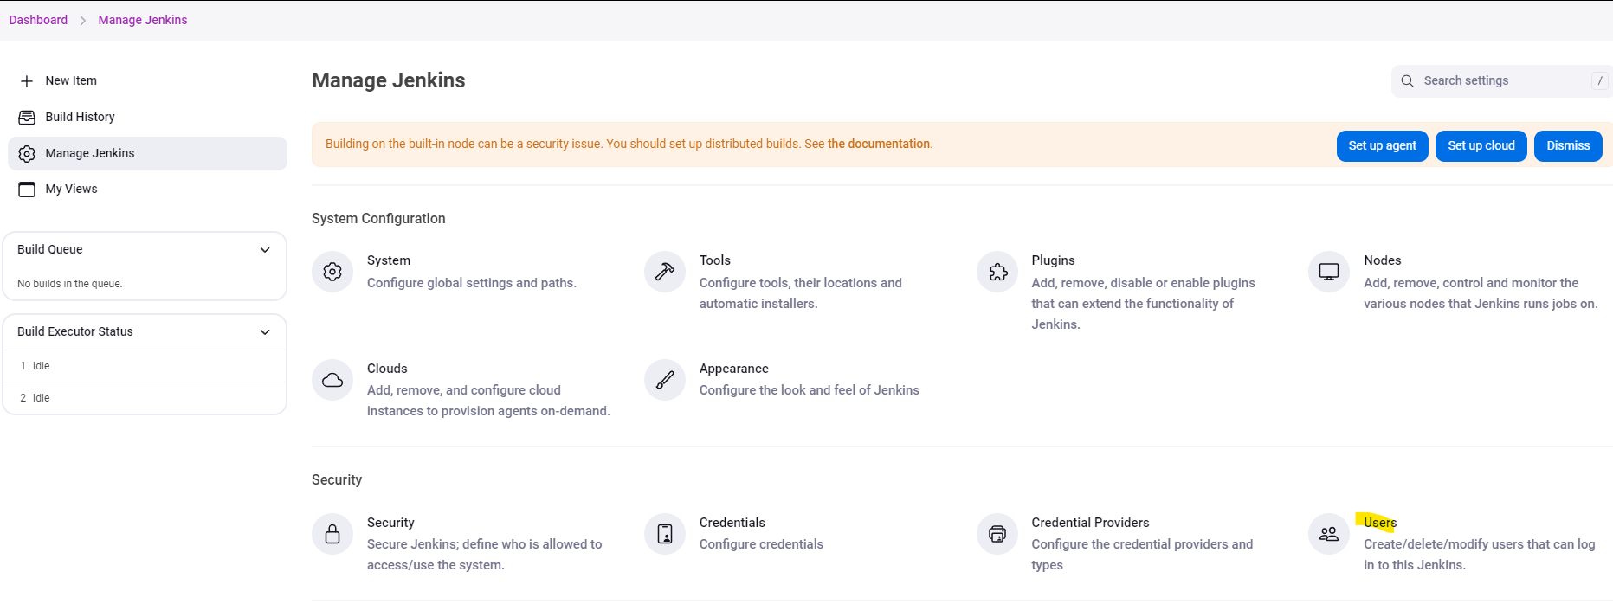

Click + Create User

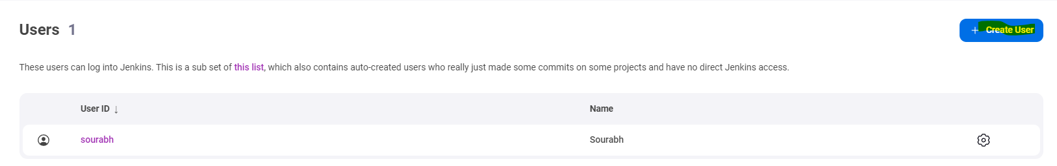

Give details like username, password, Confirm Password, Full Name and Email Address and click Create User.

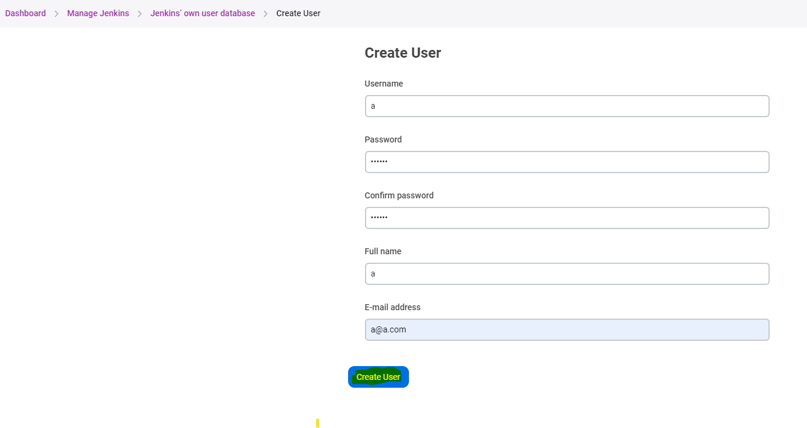

Once its created, it is displayed under Users

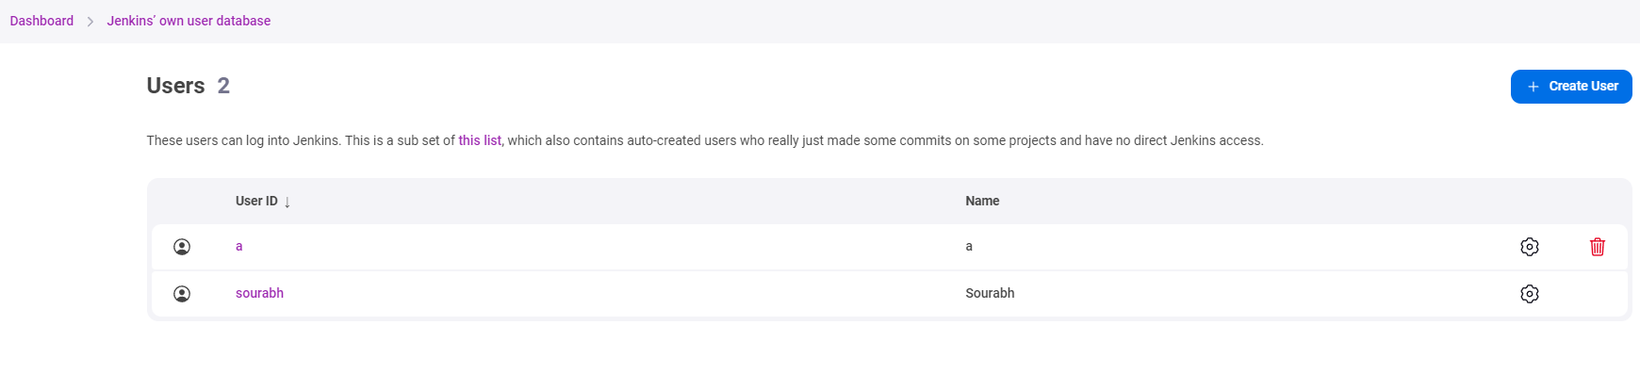

13) Jenkins Role Based Access Control **[Step 9 in Ajay Sir Notes]**

We need to create to users for performing the use case.

In our case, we have created user a and user b

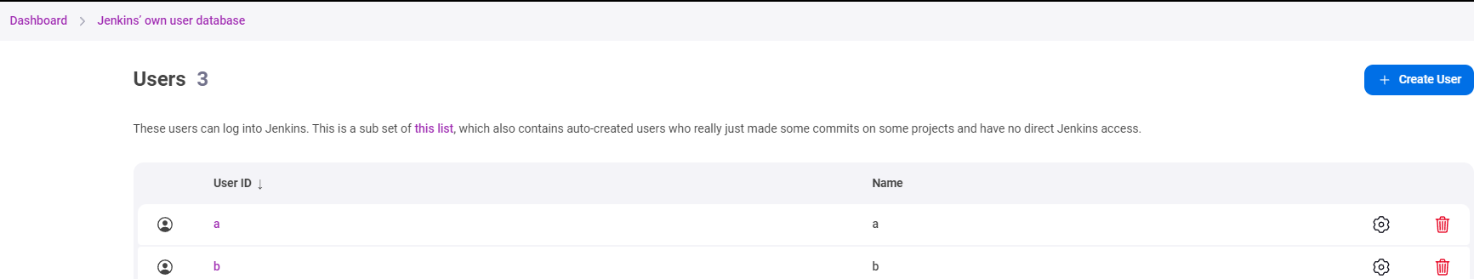

Next, we need to install Role Based Authorization Strategy plugin through available plugins.

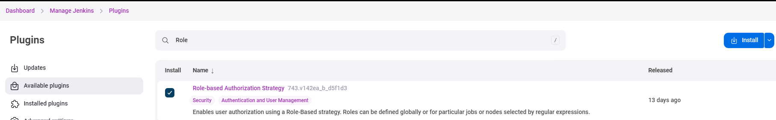

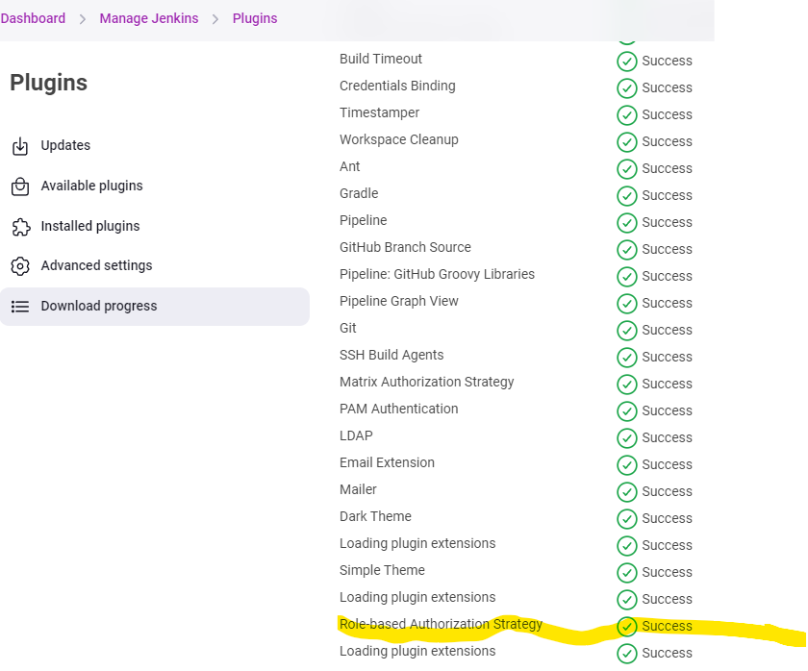

Next, we need to go to Manage Jenkins> Security

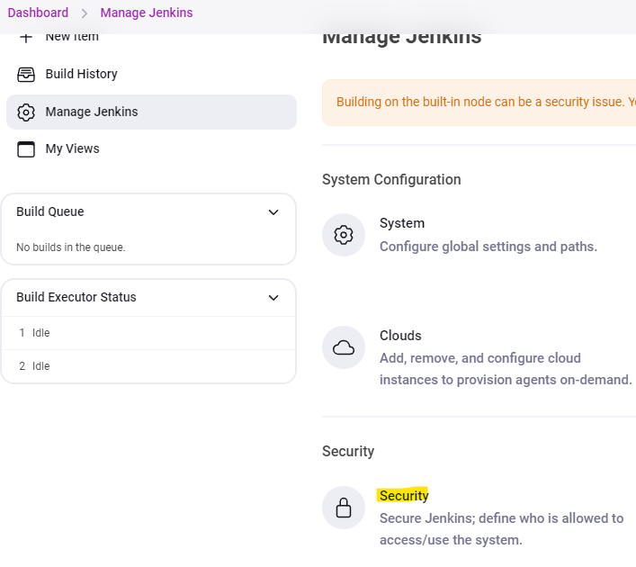

Under Authorization > Drop down and select Role-Based Strategy and click Save.

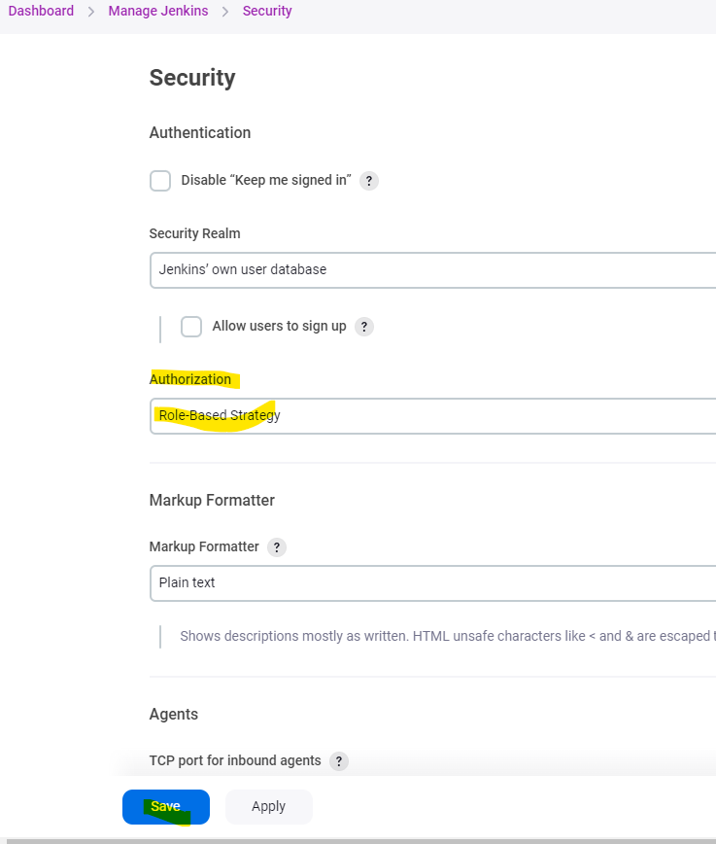

Now go to Manage Jenkins > Manage and Assign Roles.

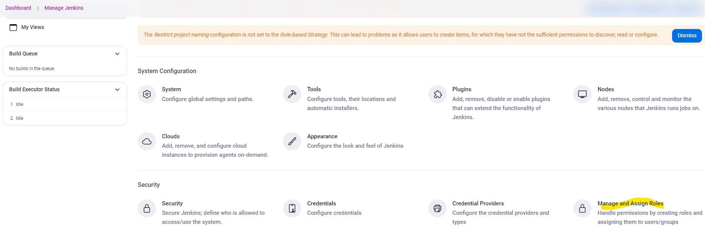

Under Manage Role > Enter “Developer” on Role to Add and click Add.

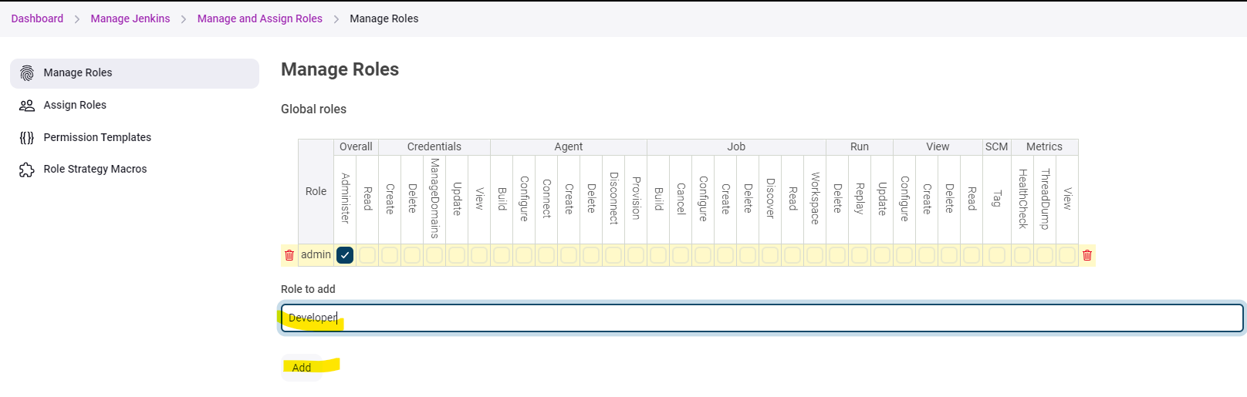

Once the role is created, check Read under Overall for the permissions to the Developer Role and click Save

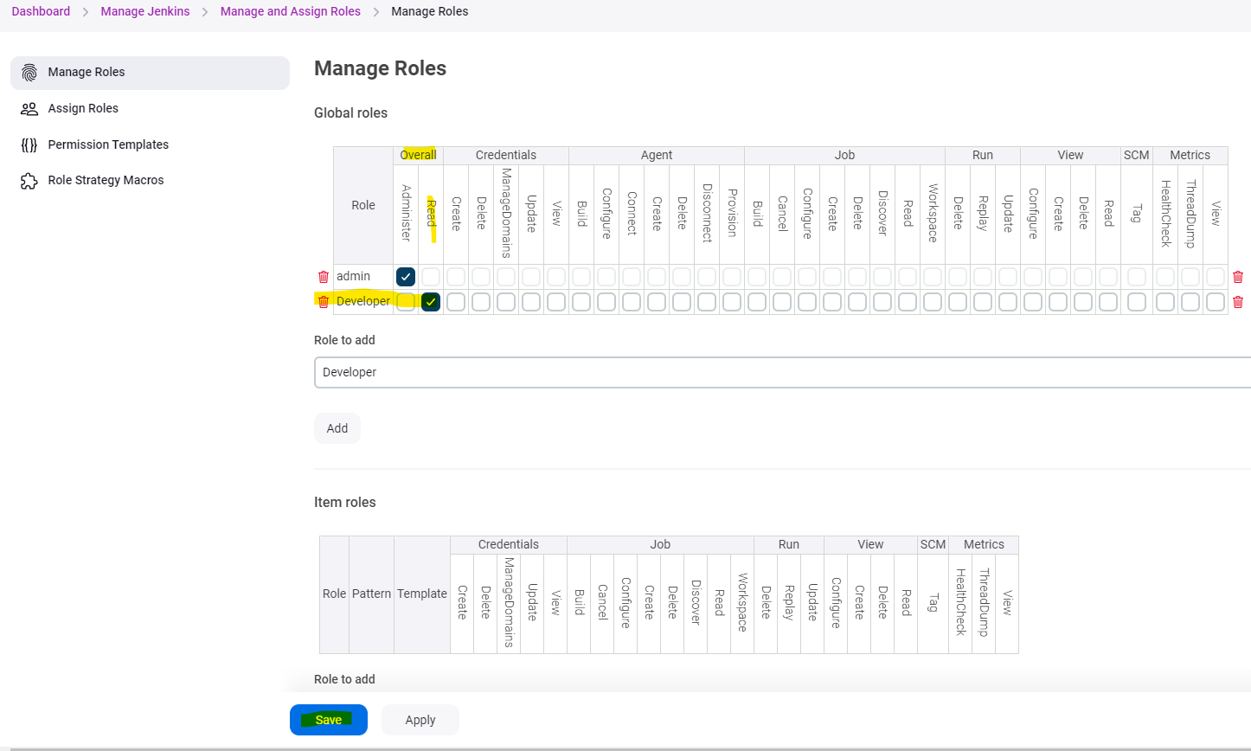

Now go to assign roles > Under Global Roles > Click on Add user

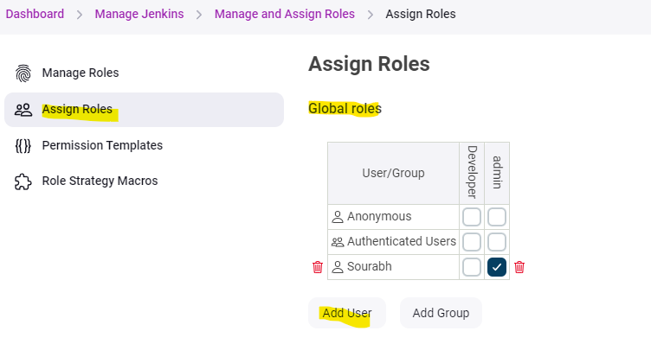

Type the User id, in our case its b and then click OK

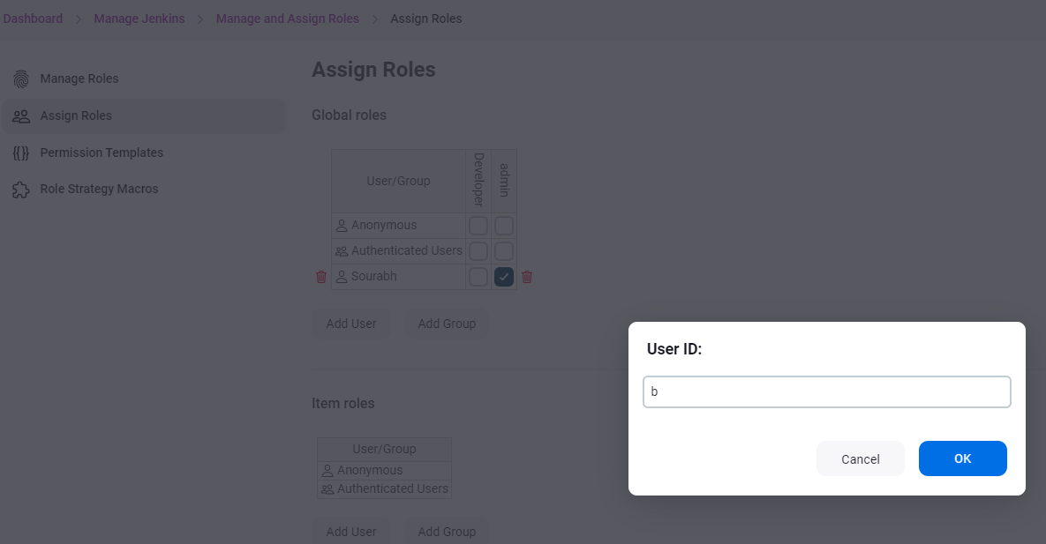

Once the user is added, we will assign developer role to it mentioned in the below screenshot and click Save.

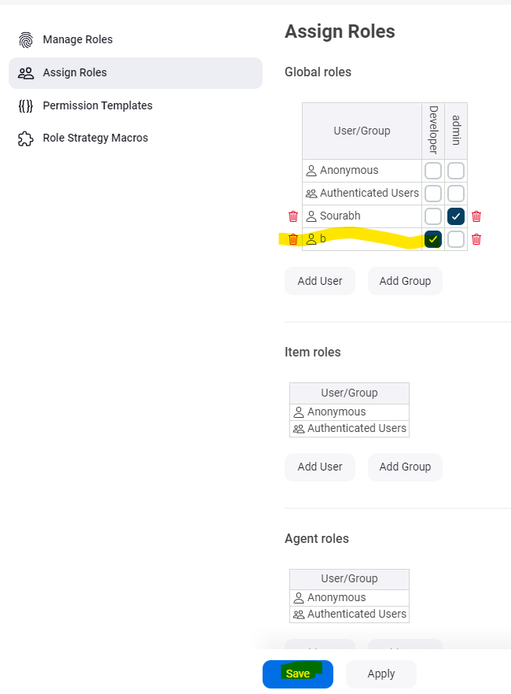

Now we will see if the role is applied properly on user b by login to Jenkins with user b credentials.

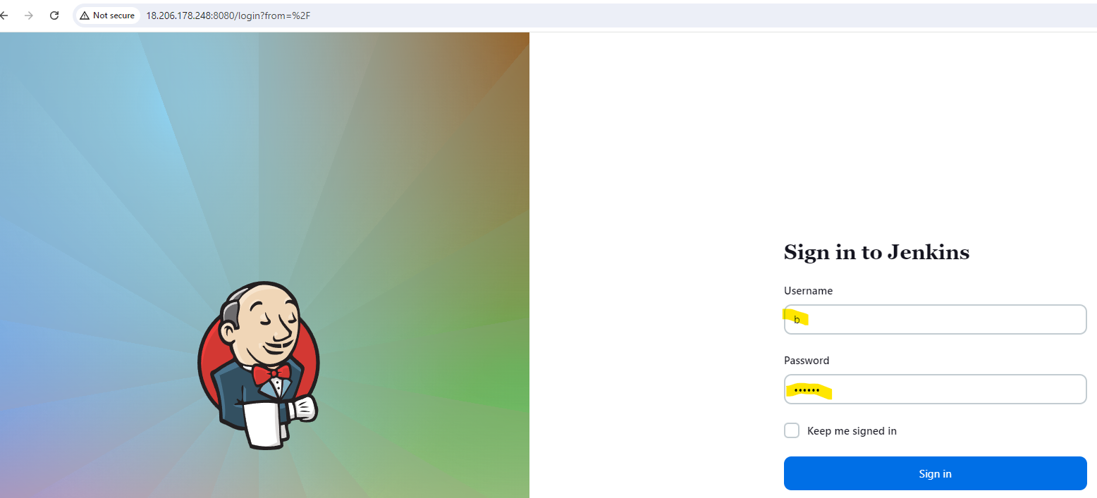

The role is applied successfully as nothing visible on the dashboard for user b

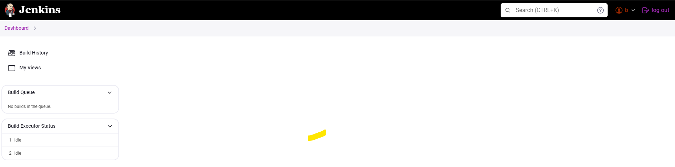

14) Use of git plugin and Clean Workspace in Jenkins. **[Step 10 in Ajay Sir Notes]**

We will create a freestyle project named test and will select the below options to clone a git repo using the project and click Save.

* Select Delete workspace before build starts
* Under Build Steps> Select Execute Shell and write steps below:

git clone <https://github.com/shashirajraja/Train-Ticket->Reservation-System.git

cd Train-Ticket-Reservation-System

ls -ltr

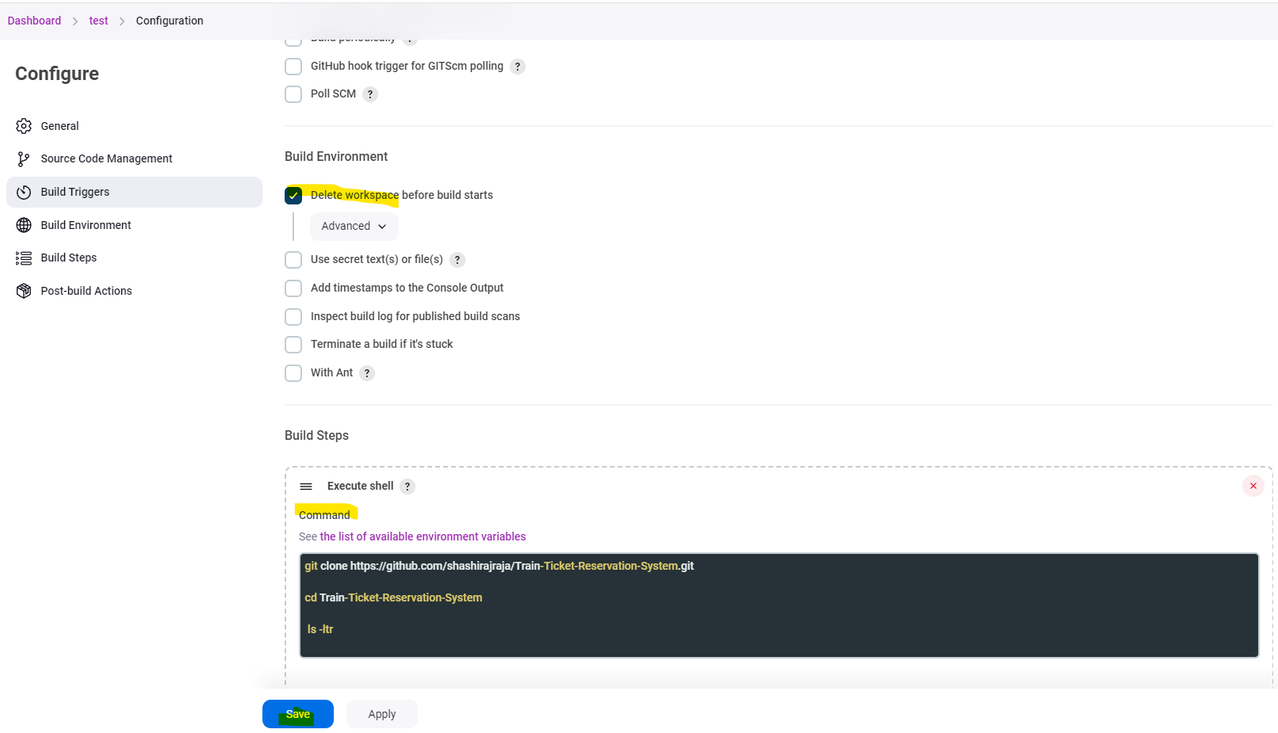

Now run Build Now on the Project “test”

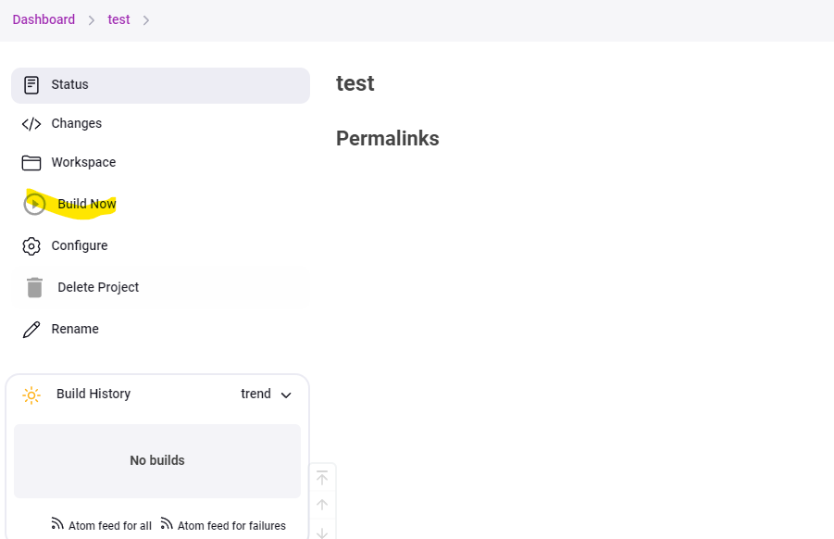

We see the build is completed successfully.

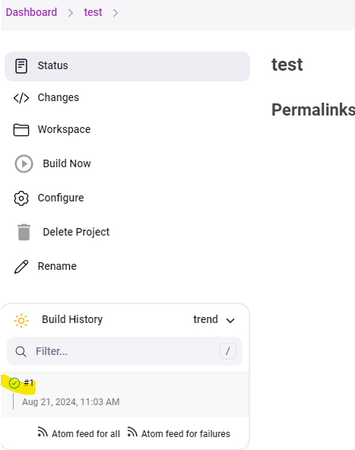

We will go into the build and check the console output to see the status. All the steps have been executed successfully.

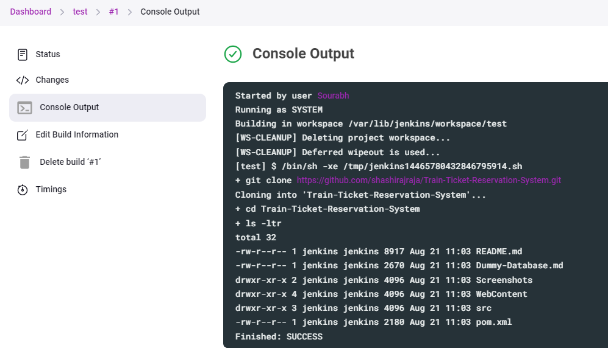

If we run the build again without selecting the Delete Workspace before build starts then it will give an error that project is already there. So we have to select it in order run the build successfully.

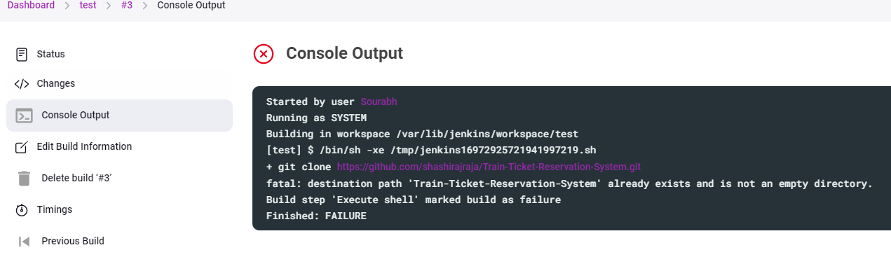

We can also use the git project path option from the source code management option. We can do it by choosing the below options

We need to select git under Source Code Management

We need to give the Repository URL under repositories

<https://github.com/shashirajraja/Train-Ticket-Reservation-System.git>

Lastly, we need to specify the branch name same as it is on the git hub link, in our case it’s */master in the git link also so we need to specify the same in the job also. Then Click Save

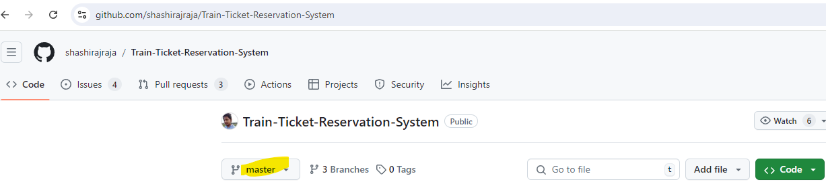

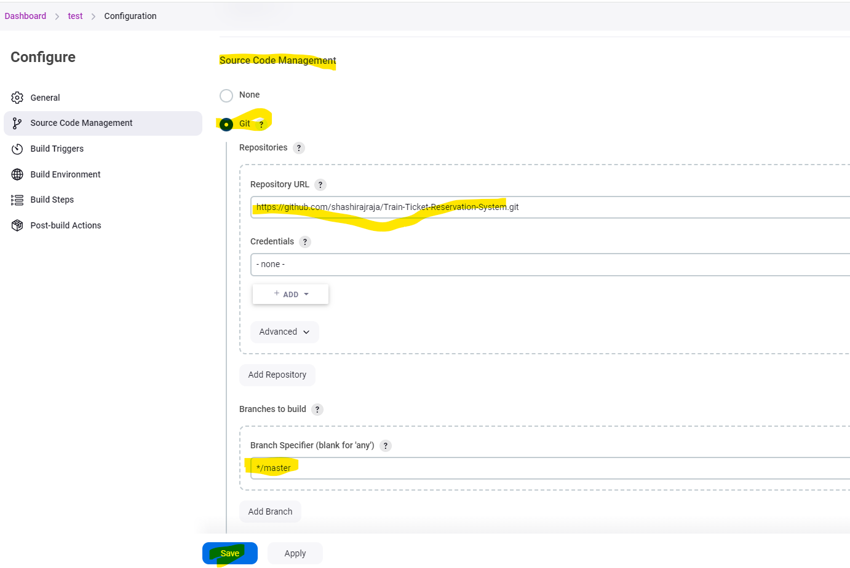

We can see that git repo is cloned in the build job.

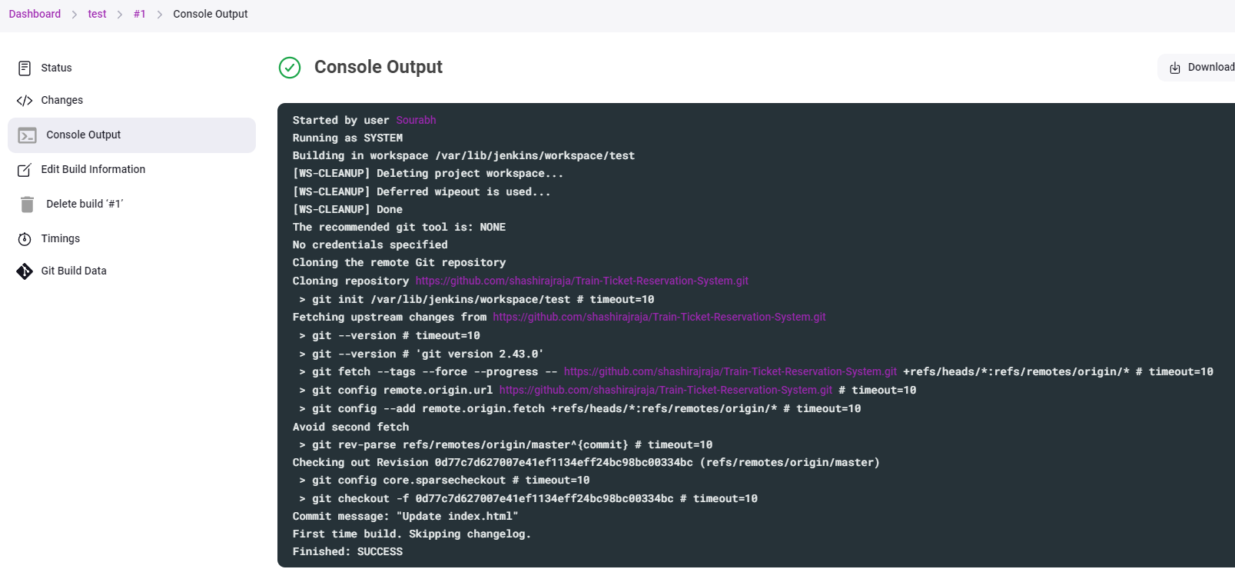

15) Trigger Build Remotely on Jenkins **[Step 11 in Ajay Sir Notes]**

We can trigger a job remotely through a Web URL in Jenkins also.

We will follow the below steps to achieve the same.

While configuring the job, we need to select Trigger builds remotely under Build Triggers, then we can give any authentication token eg new and Click Save.

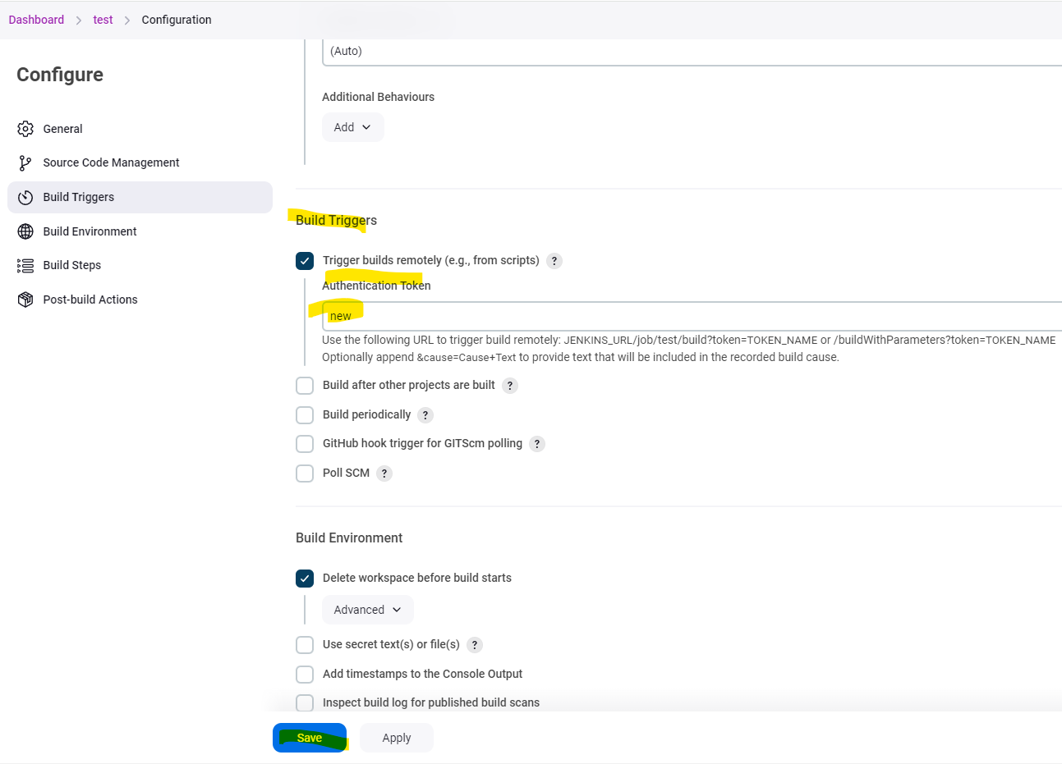

To trigger the build remotely we need use the below URL

JENKINS_URL/job/test/build?token=TOKEN_NAME or /buildWithParameters?token=TOKEN_NAME

Below screenshot is in our case



We see the 2nd Build is also executed successfully.

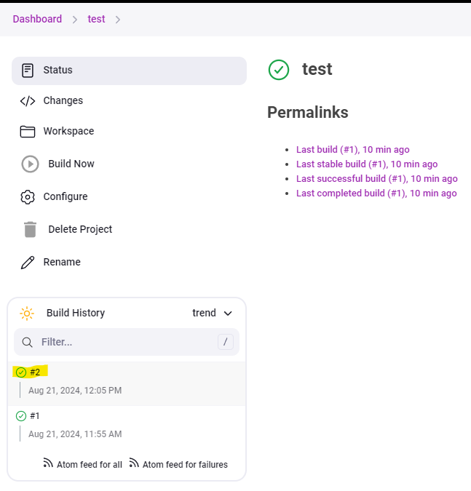

Alternate Way to run the job through remotely is by using a plugin

We need to install the plugin Build Authorization Token Root

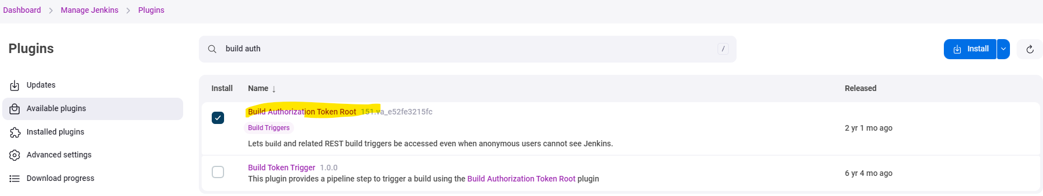

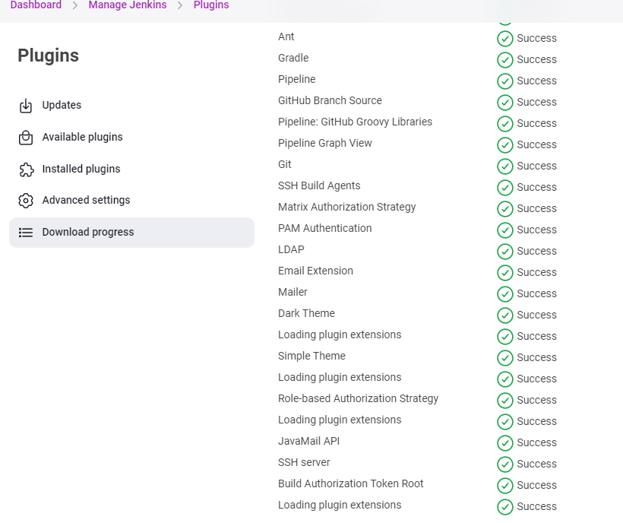

Now we will run the below URL to see if build runs.

<Jenkins_URL>buildByToken/build?job=<Job_Name>&token=<token Name>



See the Build 3 is also completed successfully.

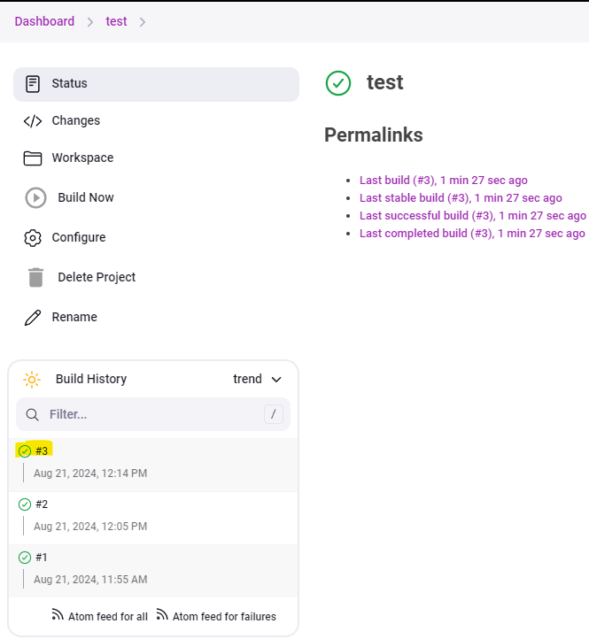

We can also run it on the Ubuntu terminal using the below command.

Just need to add “\” before the & and then run.

<Jenkins_URL>buildByToken/build?job=<Job_Name>\&token=<token Name>



Build 4 is completed successfully

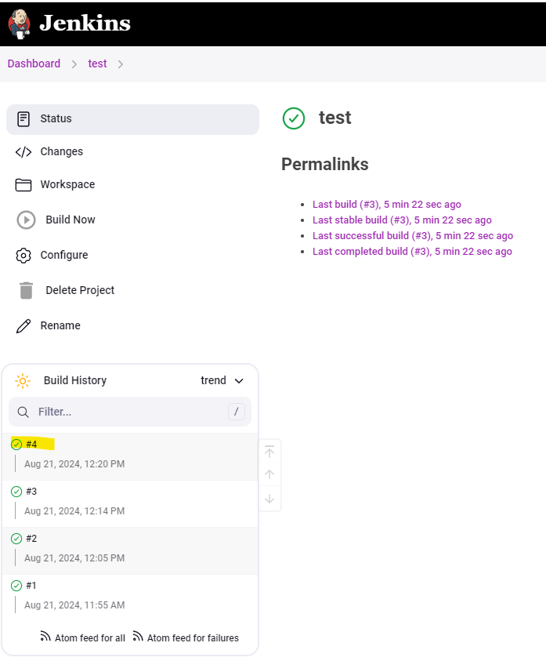

16) Build jobs periodically in Jenkins **[Step 13 in Ajay Sir Notes]**

We can set the builds to run on periodic basis. To perform that we need to follow below steps.

While configuring the job, we need to set the schedule under Build Triggers and then check Build Periodically and define the schedule and then click Save.

In our e.g., we are scheduled the job to run every 3 minutes, so whenever we save the configuration on the job, from there onwards, it should run every minute until we remove the settings. So, we have used the same job “test” for our example

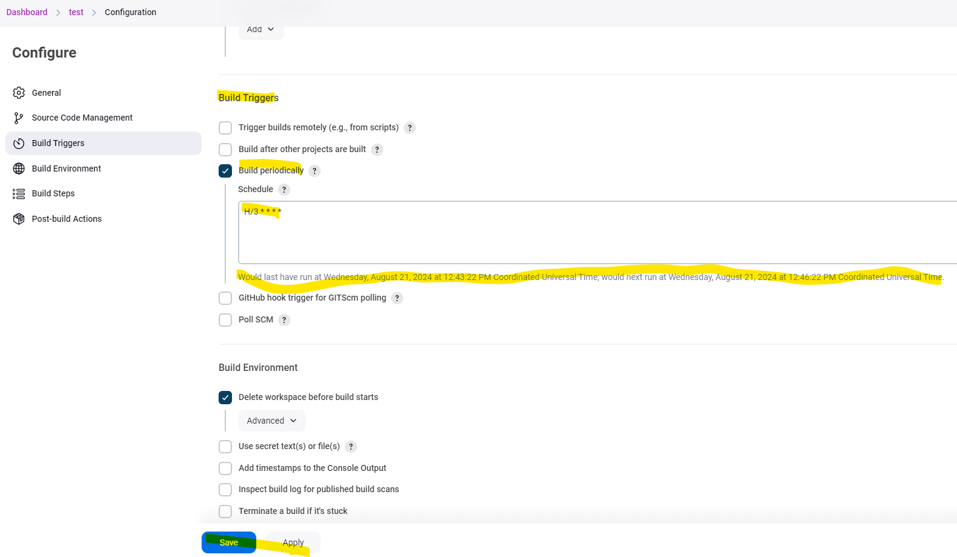

Now you can see the job runs as per the schedule after every 3 minutes.

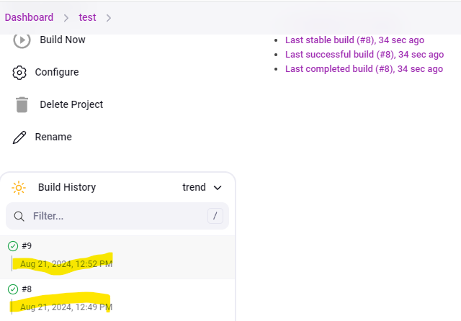

17) Poll SCM through Jenkins **[Step 14 in Ajay Sir Notes]**

This option will only check in every given time if any change happened in GIT and if there is any change in GIT, it will execute the build accordingly.

We can schedule it while configuring the build under the Build Triggers option then check Poll SCM and give the schedule on which it will check for any SCM change. Then click save

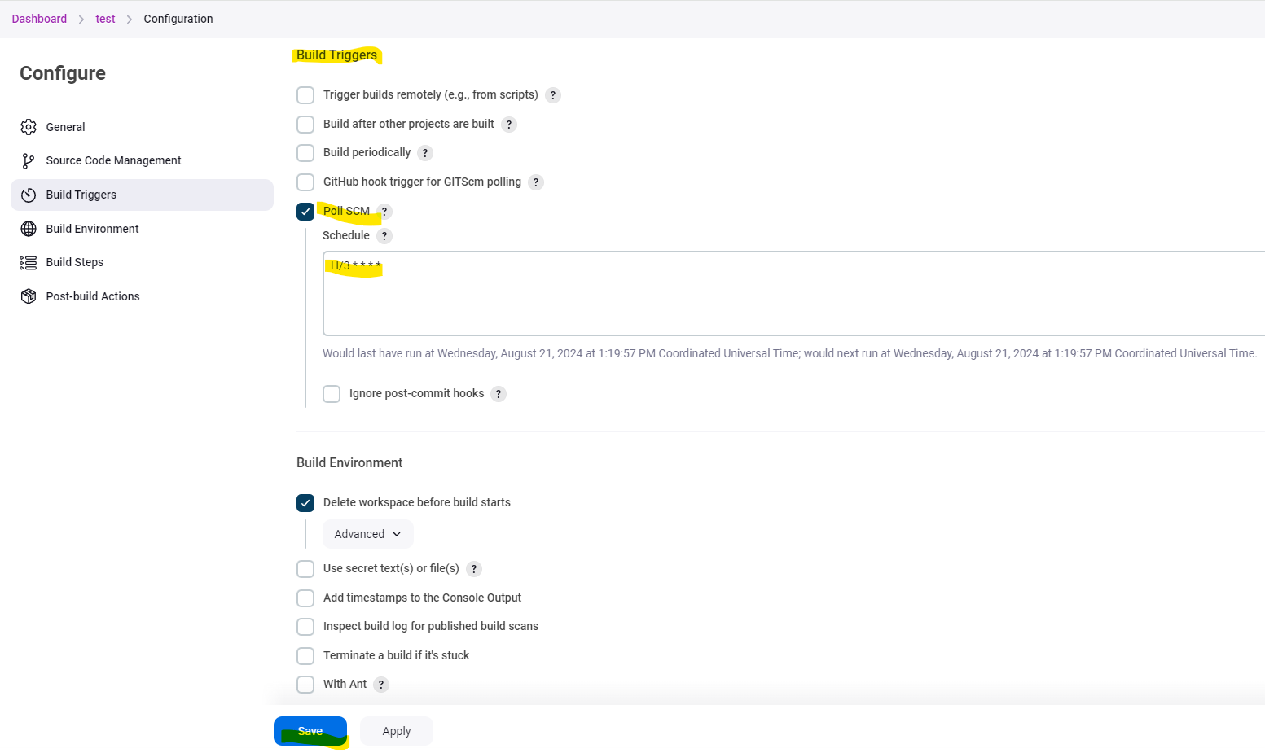

Any kind of changes which happens in git, it will be logged into Git Polling log. Below example shows no changes.

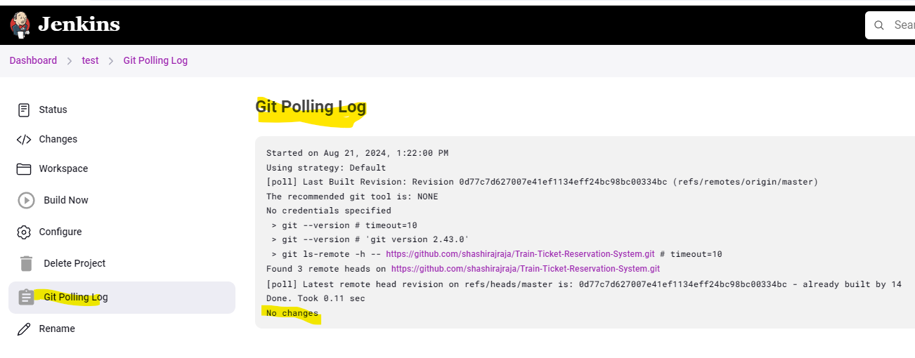

18) GitHub hook trigger for GITScm polling through Jenkins **[Step 15 in Ajay Sir Notes]**

This is used when a job needs to be triggered when there is any change in the GitHub repo.

Steps to followed are below:

While configuring the job, Check the option of GitHub hook trigger for GITScm polling under Build Triggers and then click Save.

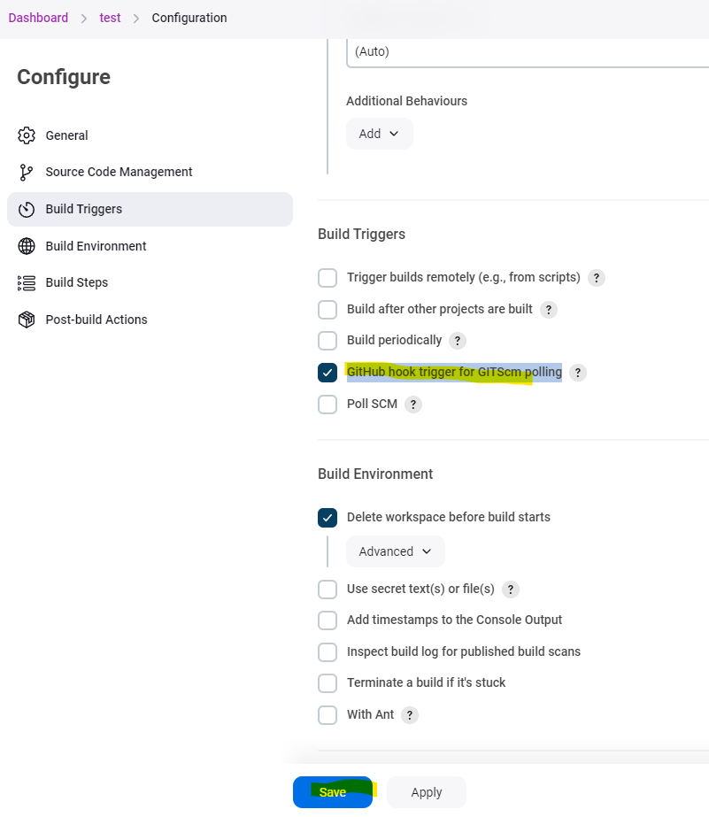

Then on the GitHub side, Go to Settings

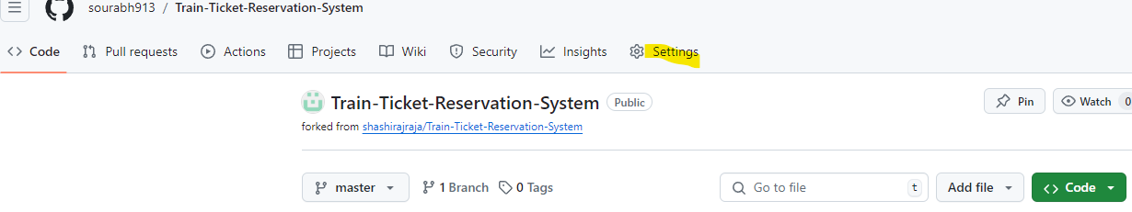

Select Webhooks > Add webhook

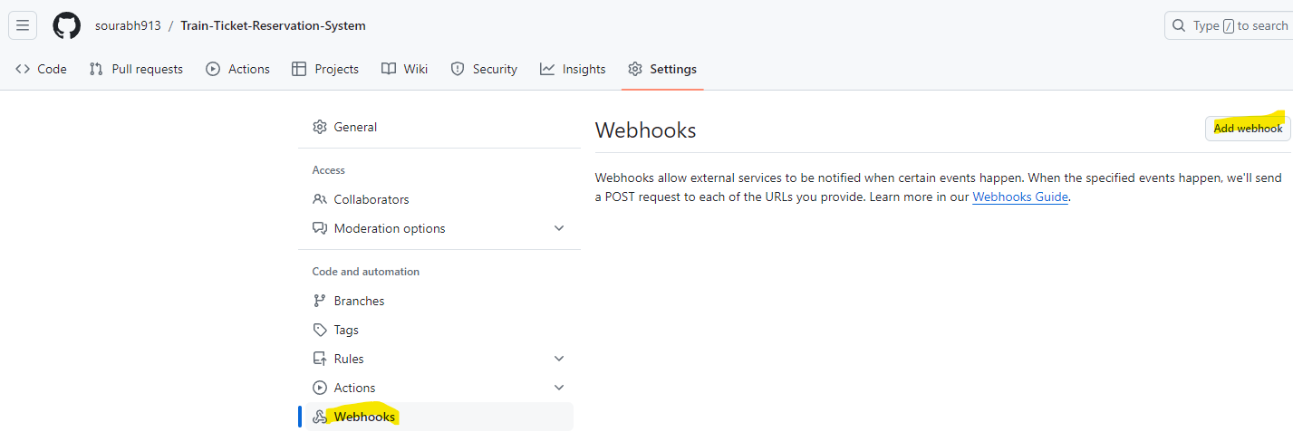

Need to put in password for your GitHub account.

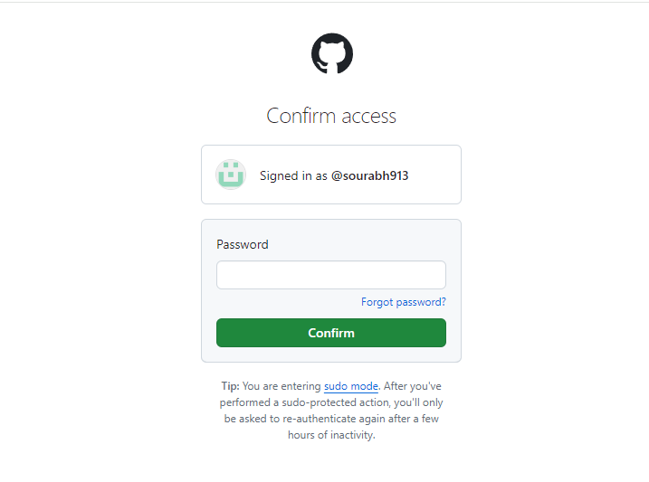

Then under the Payload URL, give the Jenkins URL /github webhook

And under Content type > Select application/json.

Click Add Webhook

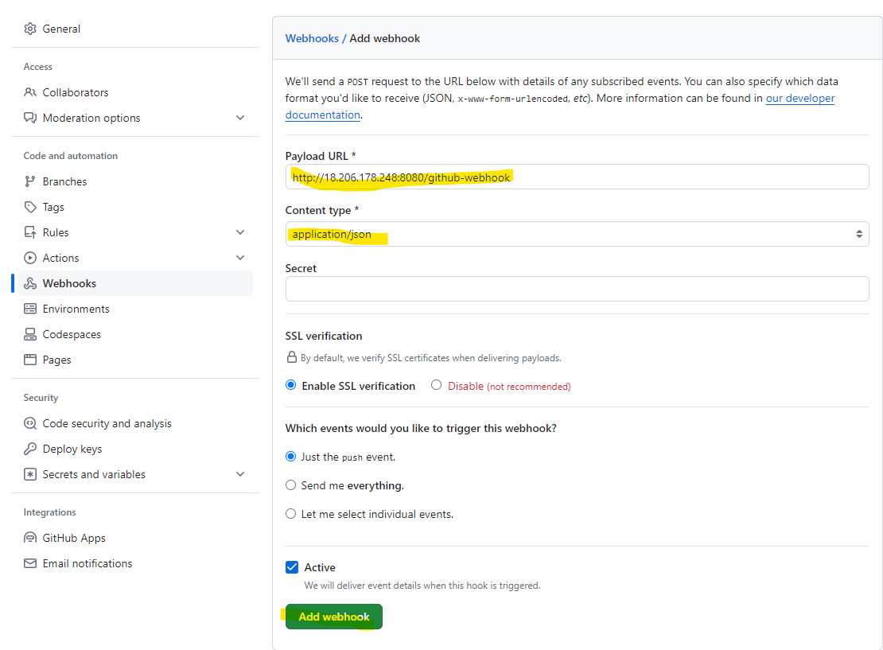

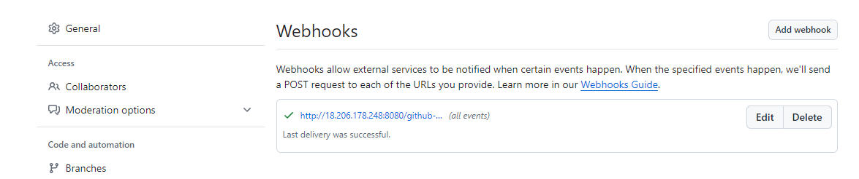

For Example, in my case I made a change under my repo > screenshots > rename viewprofila.png to viewprofile.png

Before Change

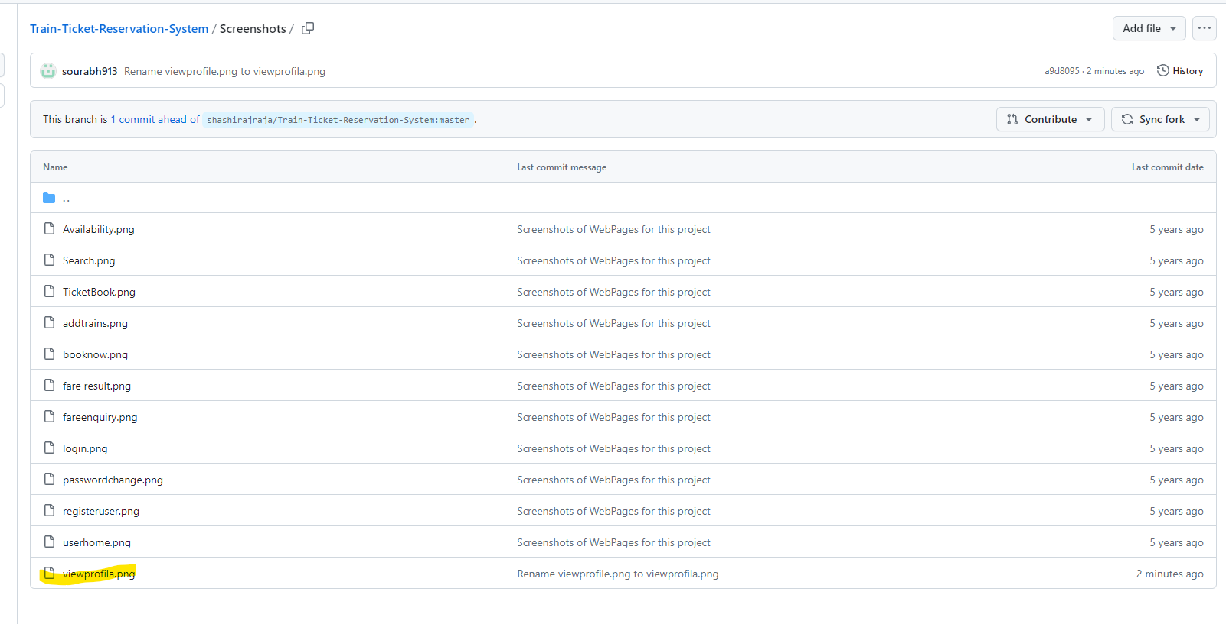

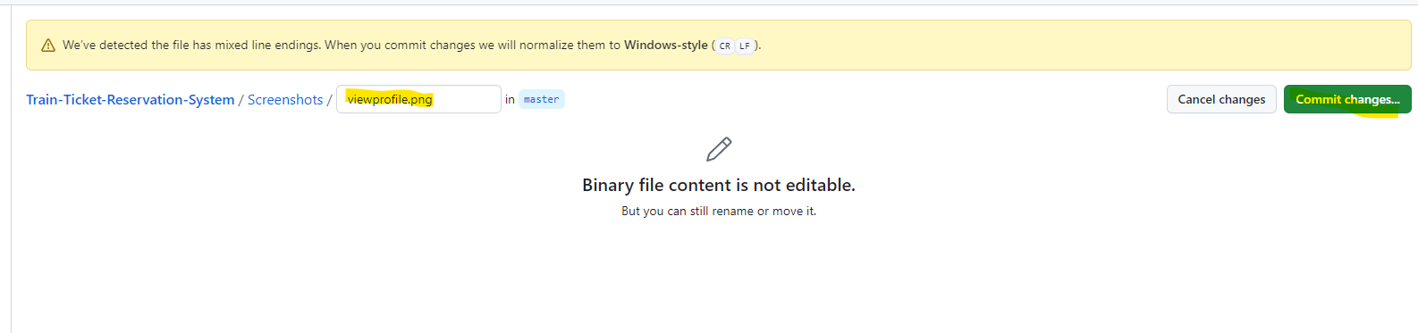

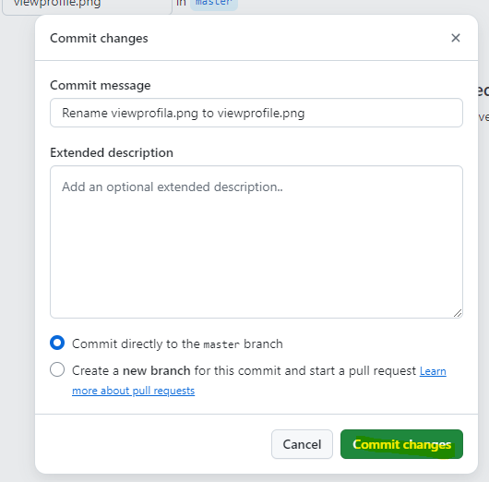

After Change

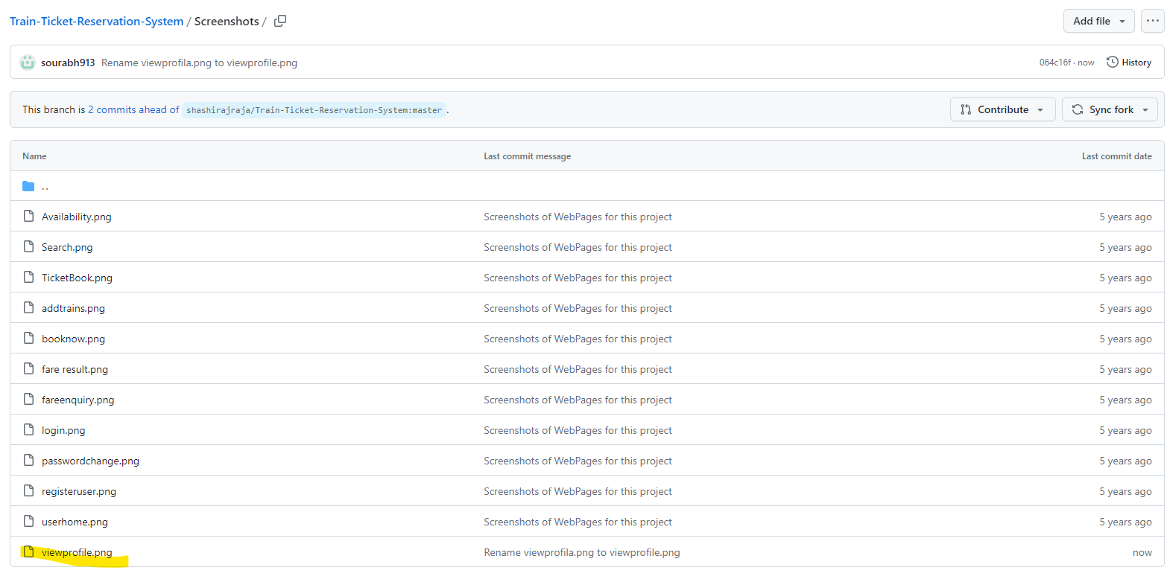

Immediately after the change, we see that build ran in Jenkins.

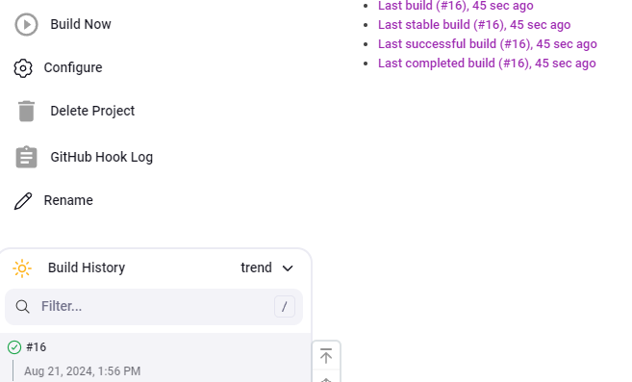

We can see the changes in the console output reflected successfully

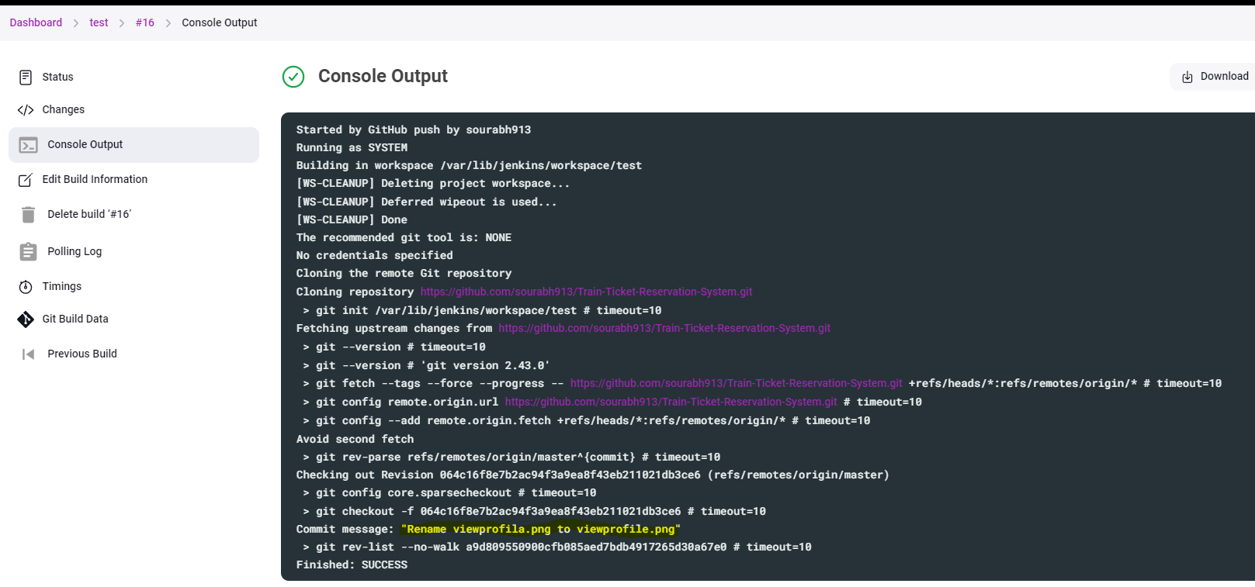

19) Setting Environment Variables in Jenkins. **[Step 16 in Ajay Sir Notes]**

We can set the Custom Variables under Build Steps > Execute Shell then click Save

For Example -

name=Sourabh

echo "My name is ${name}"

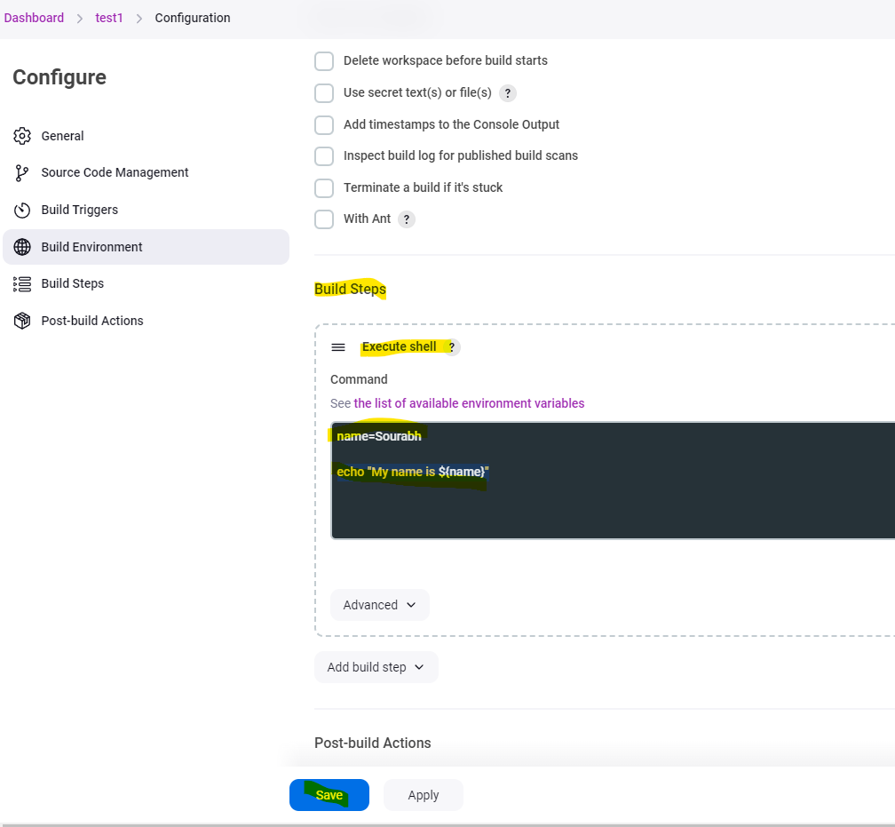

Output of the above build

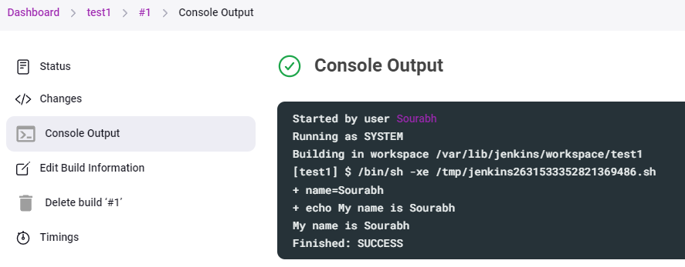

System Variables can be setup by using reference on the below link in Jenkins

Jenkins URL/env-vars.html

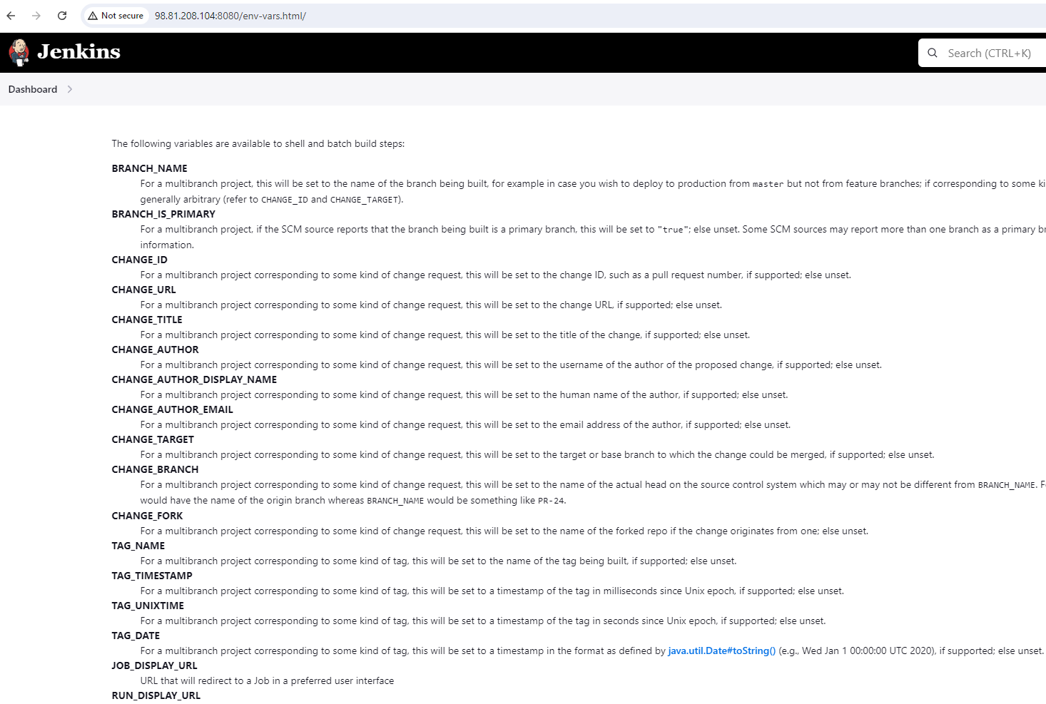

20) Setting Global Environment variables in Jenkins **[Step 17 in Ajay Sir Notes]**

Global Variables are the variables which can be used in any or all jobs. Also, they do not need to define in each job.

Follow the Steps to setup Global Variables

Goto Manage Jenkins > System

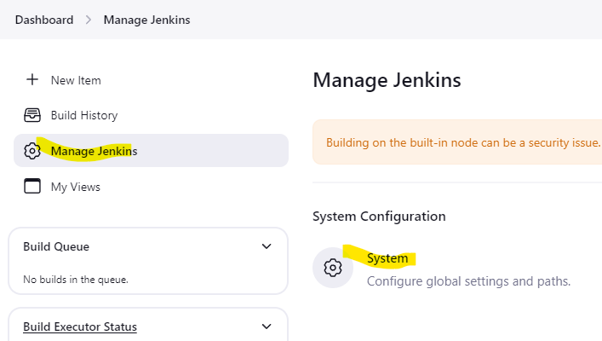

Under System > Global Properties and then check Environment Variables. Then Click Save Example

Name > class

Value > echo "My name is ${name}

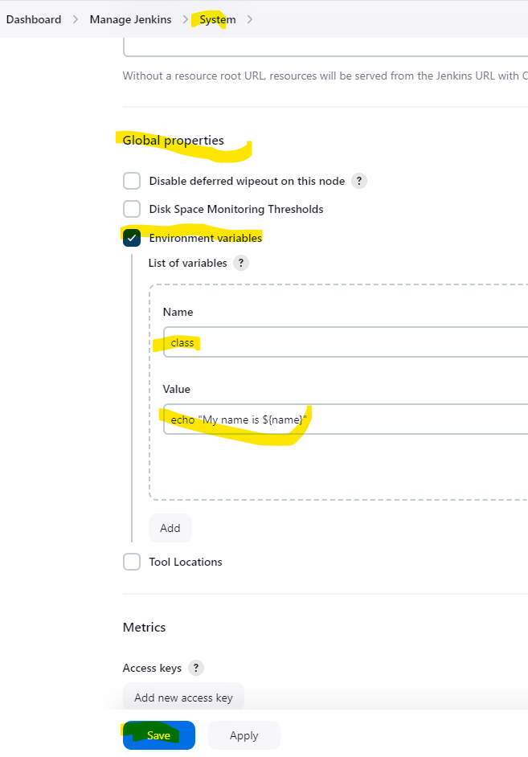

21) Parameterized Jobs in Jenkins [**Step 18 in Ajay Sir Notes]**

In this we can define a value/parameter in job.

Steps on how we can configure parameterized job in Jenkins using example

Configure the job and Under General check the option of “This project is parameterized” then select drop down from Add parameter and we can select from a list of below parameters and then Click Save

Boolean Parameter

Choice Parameter

multi-line string parameter

Credentials Parameter

File Parameter

Password Parameter

String Parameter

Run Parameter

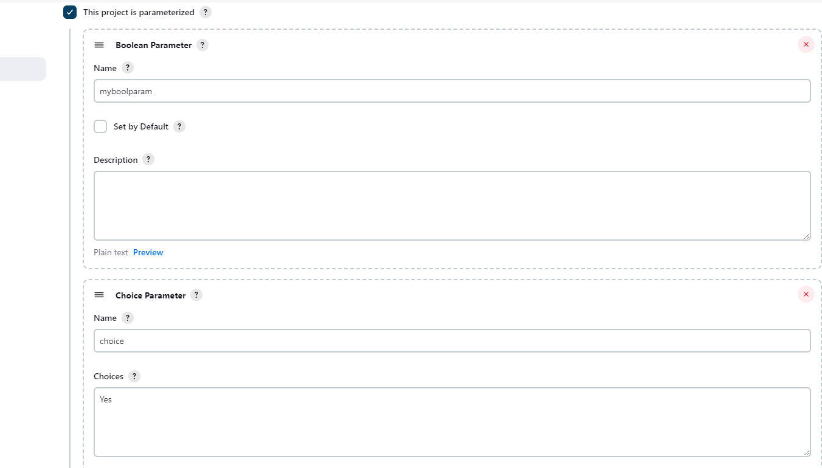

22) How to create a pipeline in Jenkins [**Step 19 in Ajay Sir Notes]**

Now we will see, how to create a pipeline in Jenkins

Steps to create a pipeline

We need to create two jobs at least and create a dependency on each other (Upstream/Downstream)

Example - Dev, Test, Prod

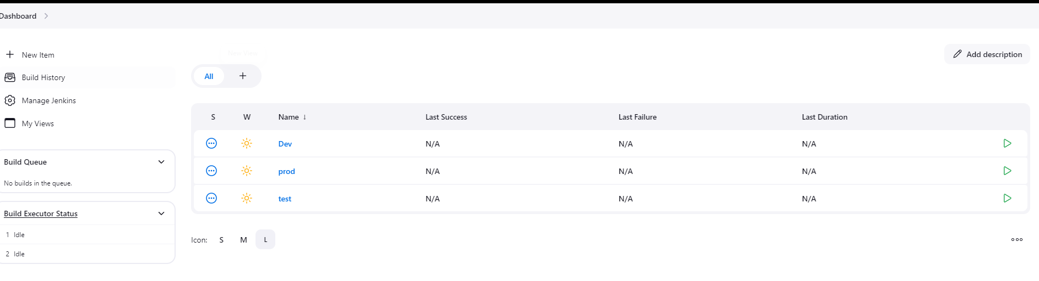

Now Install a plugin build pipeline

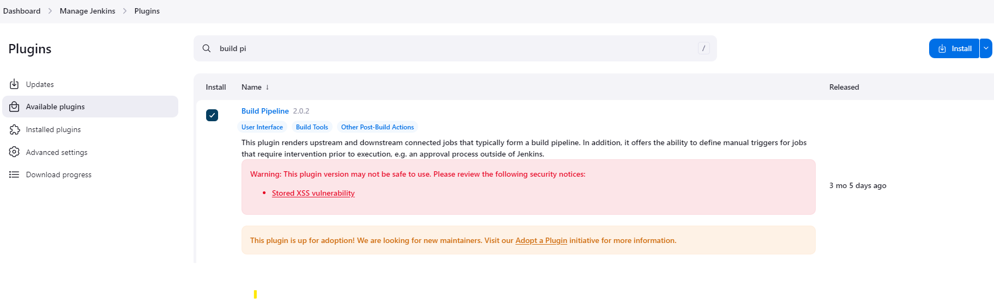

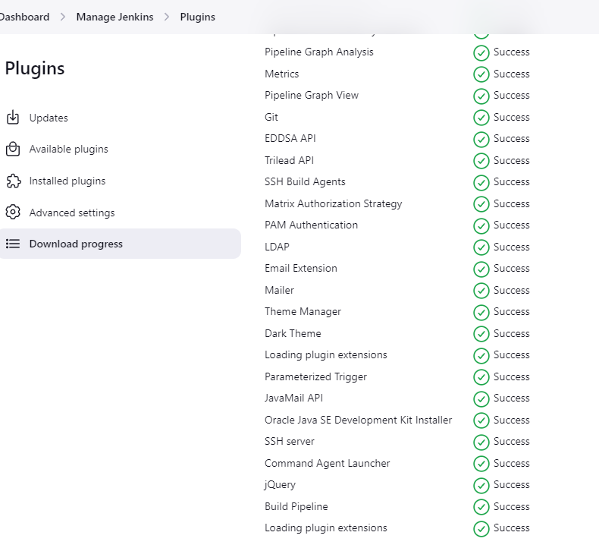

set project dependency on test to dev and prod to test

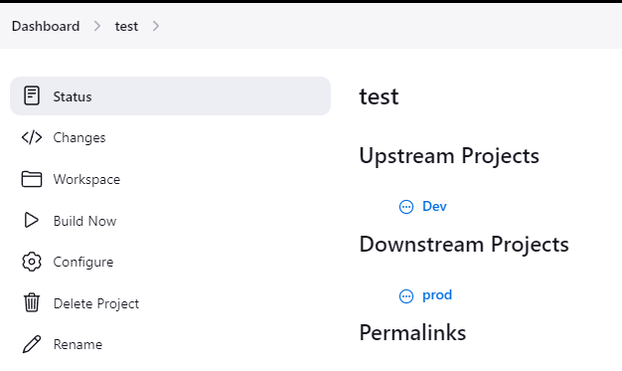

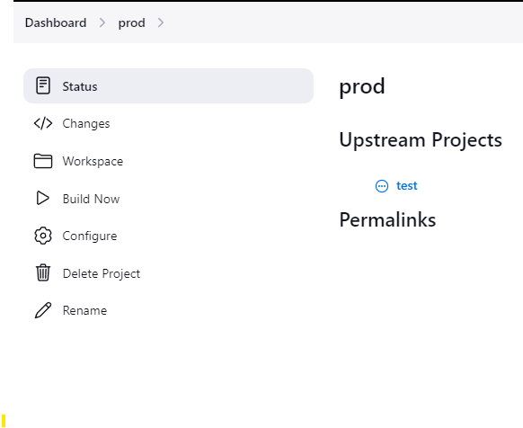

Now click on + sign on dashboard

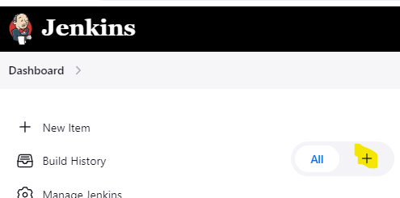

Give Pipeline view a name and select Build Pipeline View

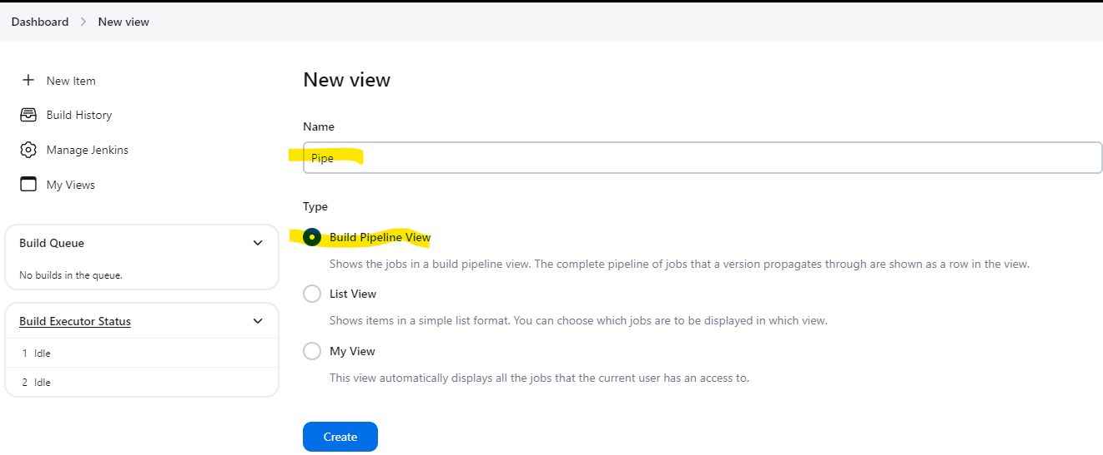

Select Initial Job as Dev under Pipeline Flow and Click OK.

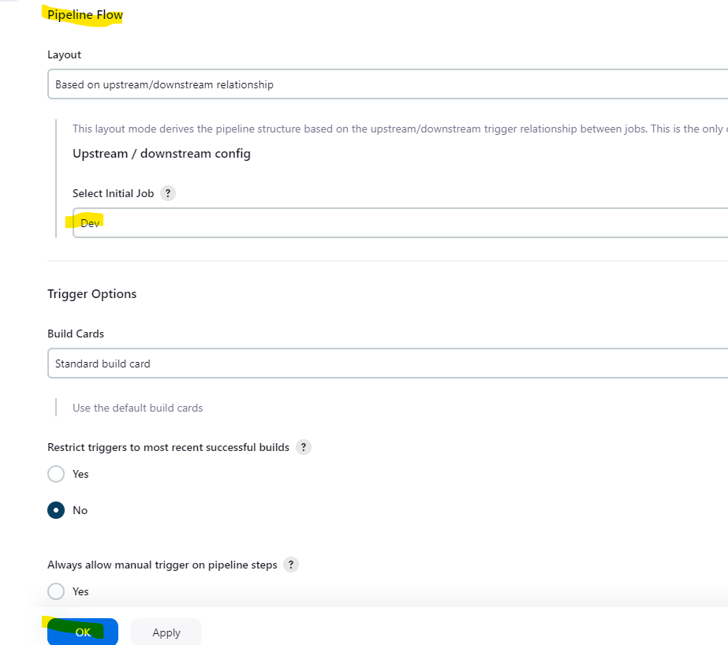

Now will run the Build Pipeline and see the output below

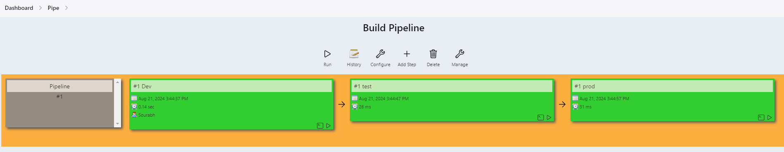

23) Running job on Jenkins Worker/Slave node [**Step 21 in Ajay Sir Notes]**

In this, we will setup a Jenkins Master and Worker Nodes and will establish connection between the two and run the job on Worker Node

Steps that needed to be followed

* We need to create tow EC2 instances (Jenkins Master and Jenkins Worker) Jenkins master should have Jenkins installed on it. Nothing needs to be done on Worker Node apart from OS update and upgrade and install open-jdk also



* Once the Instance are created, we need to setup password less authentication between Master and Worker. We need to follow the below steps for the same.

Run the commands in Jenkins Master to generate a public and private key.

ssh-keygen

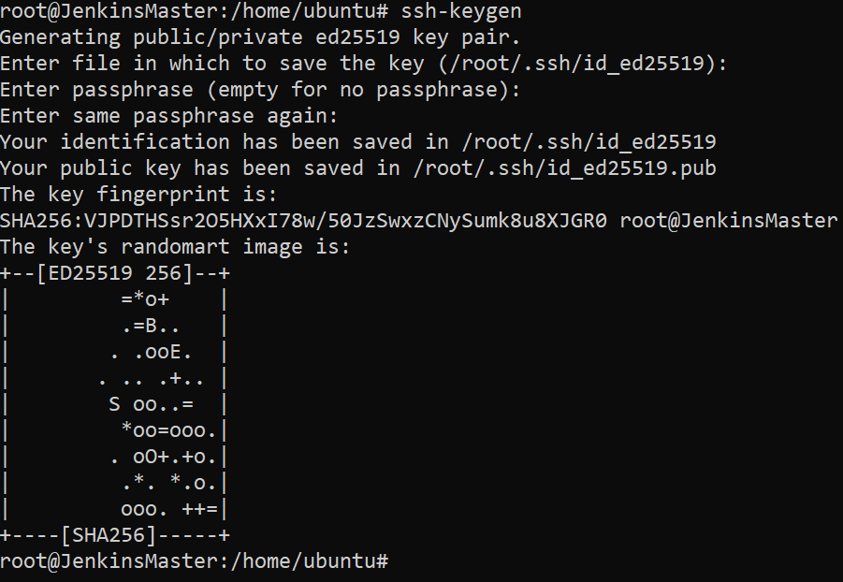

Now we need to copy the contents of the public key (e.g. id_ed25519.pub) from the path /root/.ssh/ to worker node /root/.ssh/authorized_keys file

cd /root/.ssh

cat id_ed25519.pub (copy the contents and append in the worker machine authorized_keys file)

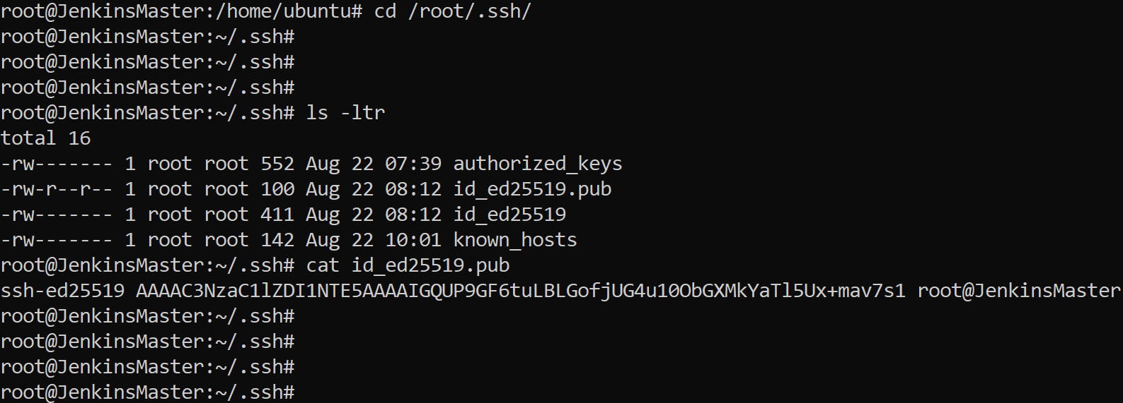

On worker Node

Cd /root/.ssh

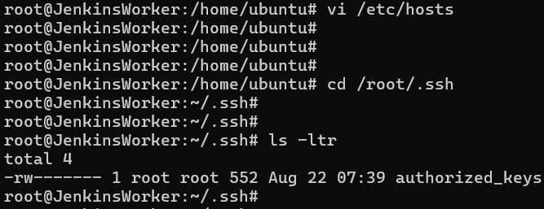

cat >> authorized_keys

add the copied content from master node

ctrl+C

Verify once by doing

cat authorized_keys (entry is made or not) 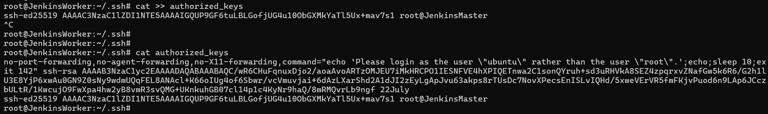

* Now we will test whether password less ssh is working or not doing ssh from Jenkins Master to Jenkins Worker. Below screenshot shows it worked.

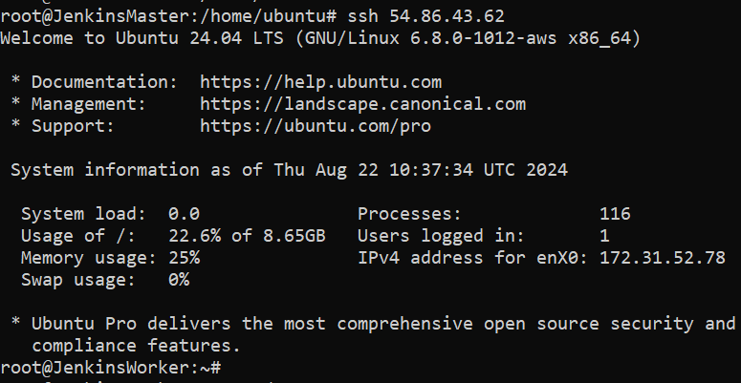

* Now we will configure Jenkins to add the node as Worker Node.

From Jenkins dashboard, go to Manage Jenkins > Security

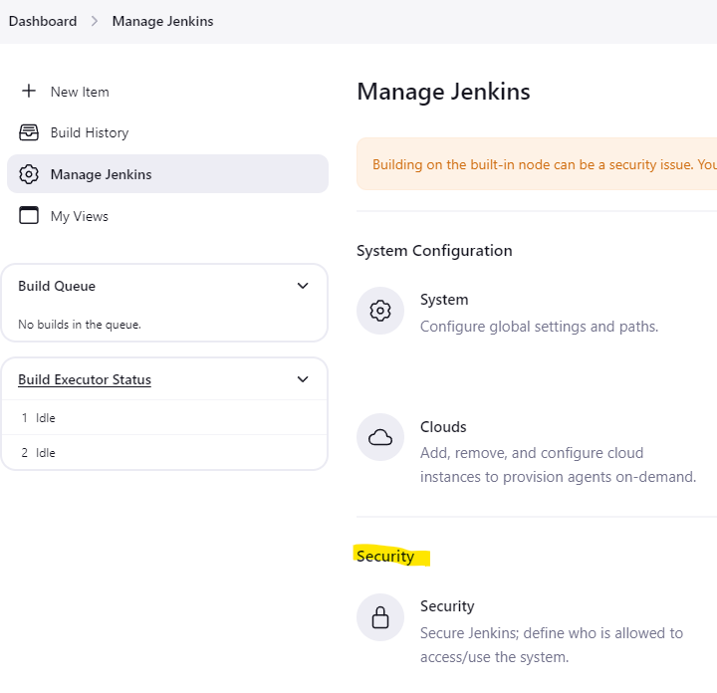

* Under Agents change the TCP port for inbound agents to Random and click Save

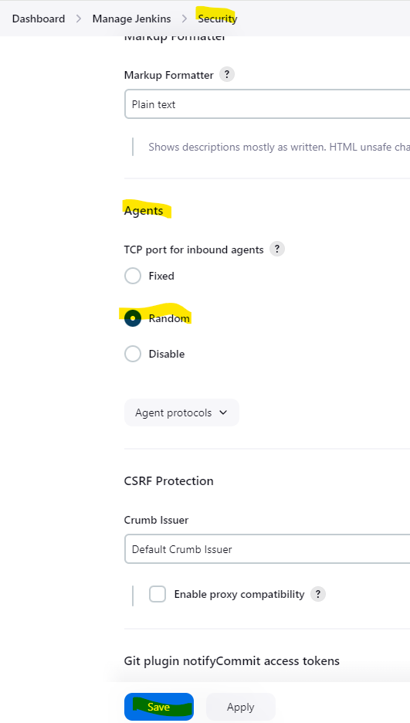

* Now go to Manage Jenkins > Nodes.

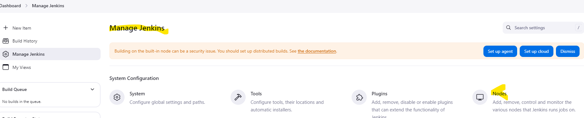

* Click on + New Node.

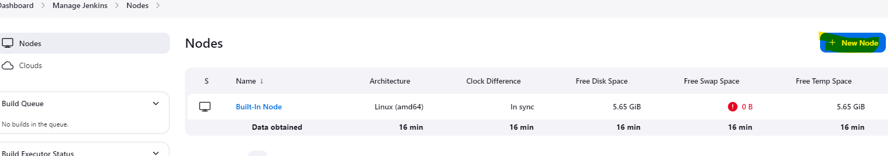

* Give a Name to the node e.g. Worker and select permanent agent and click create.

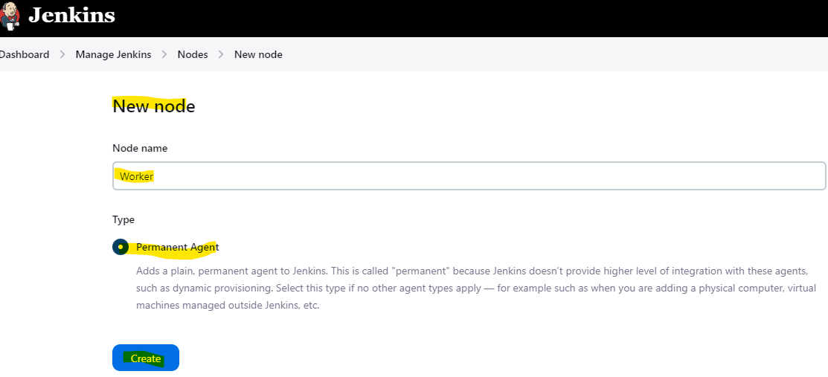

* Now give the Remote root directory (/var/lib/Jenkins) and under Labels we can give any name e.g. Worker and click Save.

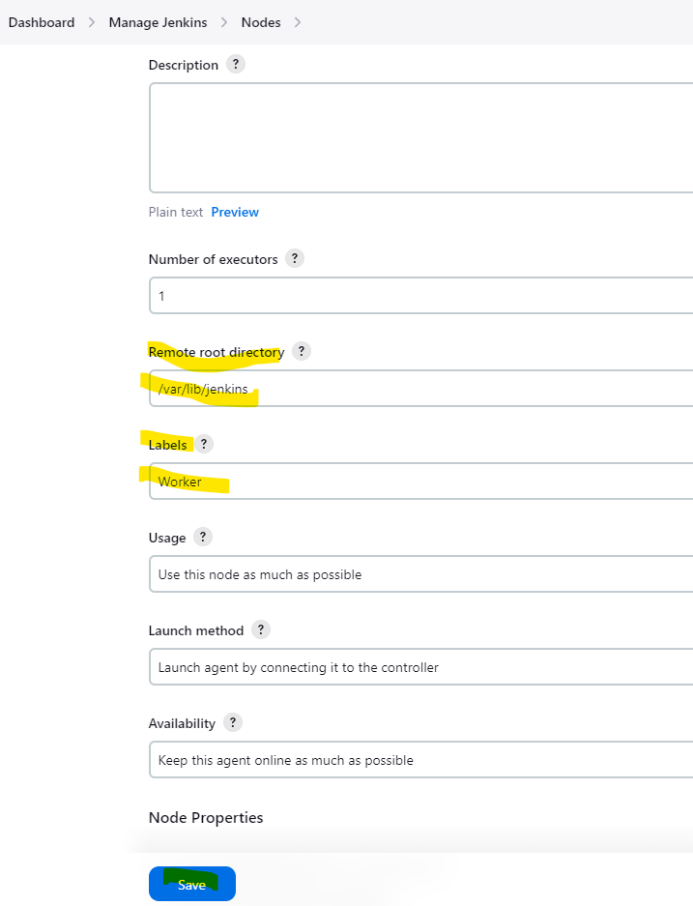

* Now you will see the Node showing added in Nodes dashboard.

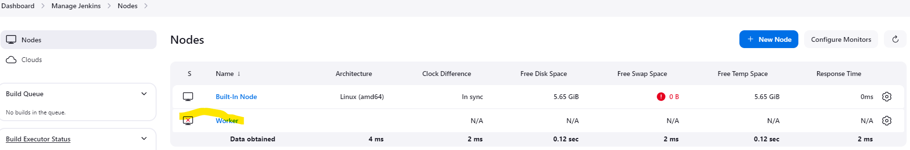

* Now we will click on Worker node.

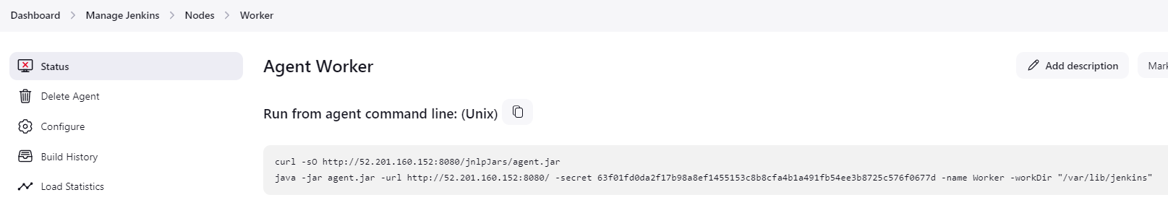

* We will copy the commands in the screenshot and run them on the worker node ubuntu terminal.

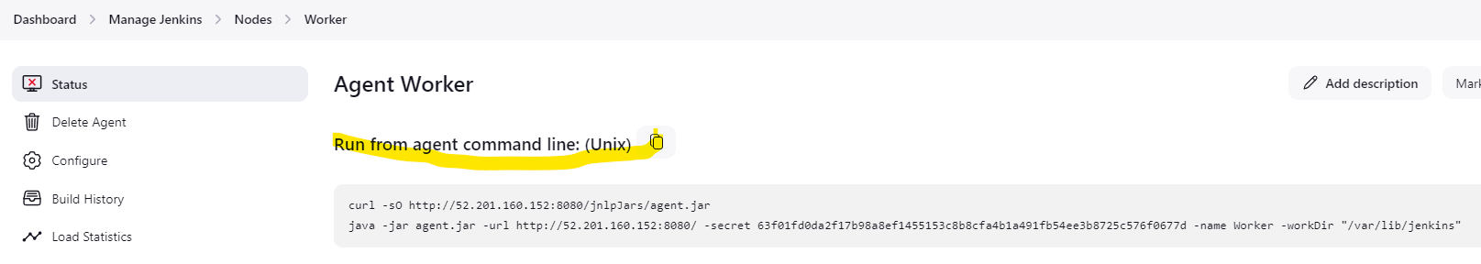

* The commands are run on the worker ubuntu terminal successfully. In the below output it shows connected, which confirms that worker is online.

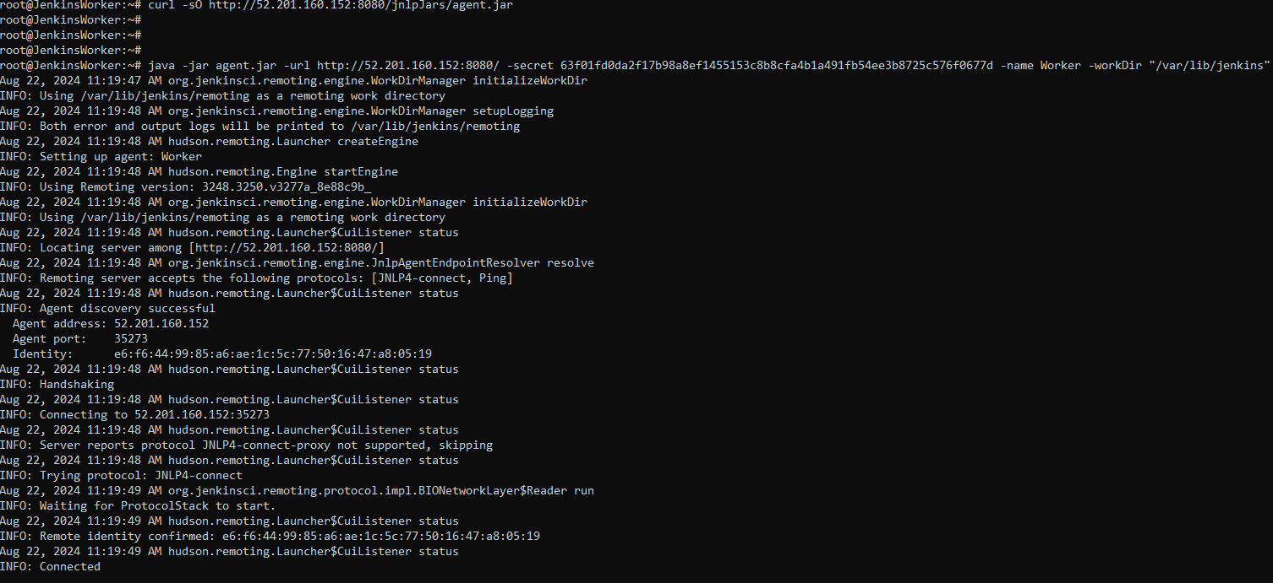

* We can see in the node dashboard that Worker in Online now as a node.

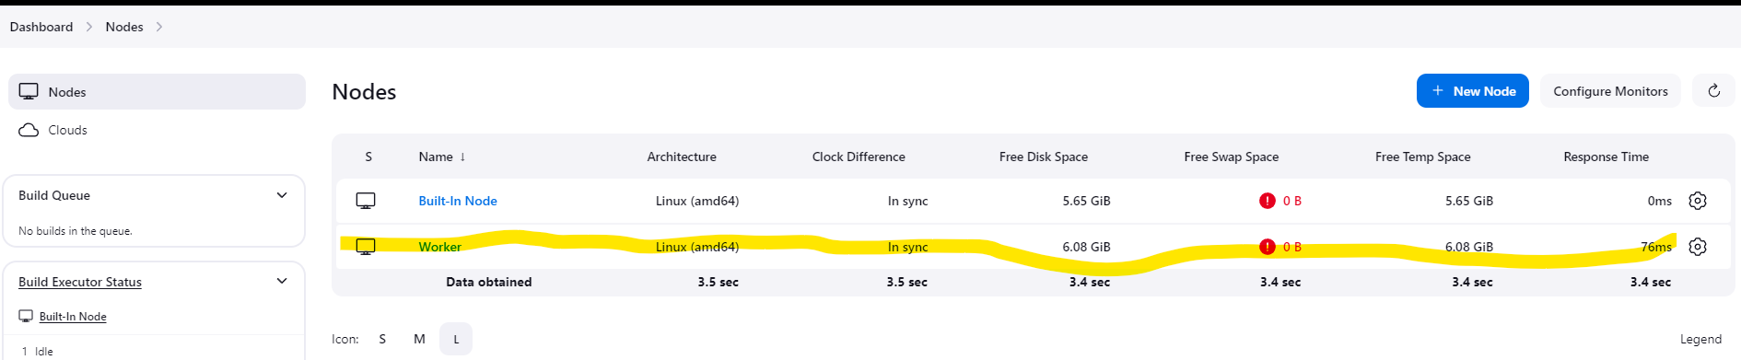

* Now we will run the job on the worker node, for that we will create a freestyle project and do the following configuration.

While configuring, we will select Restriction where this project can be run under General tab.

Then we will select our worker node from the Label Expression

e.g. in our case its Worker

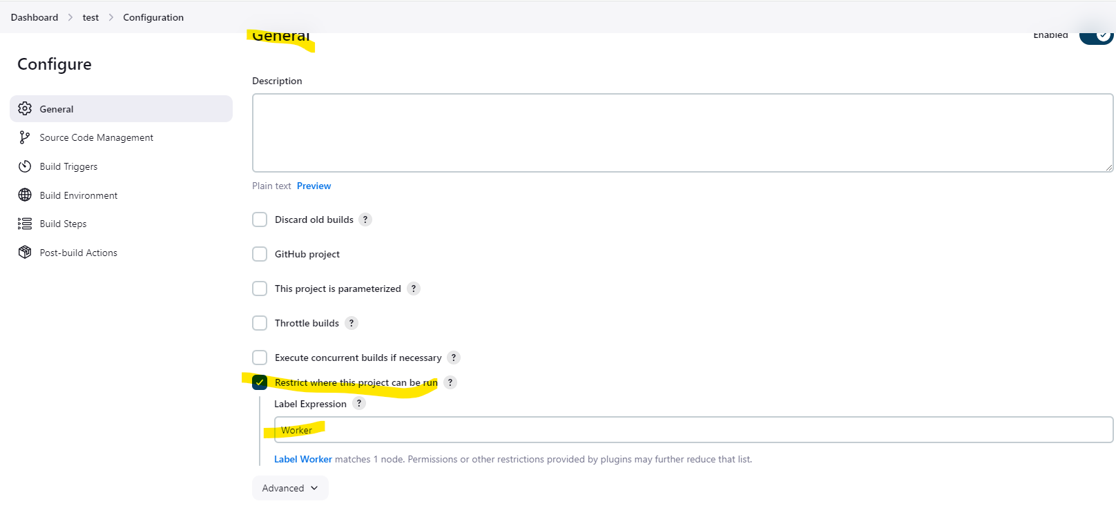

Then we give some commands which we want to run as an example on the worker node under Build Steps > Execute shell

Then Click Save

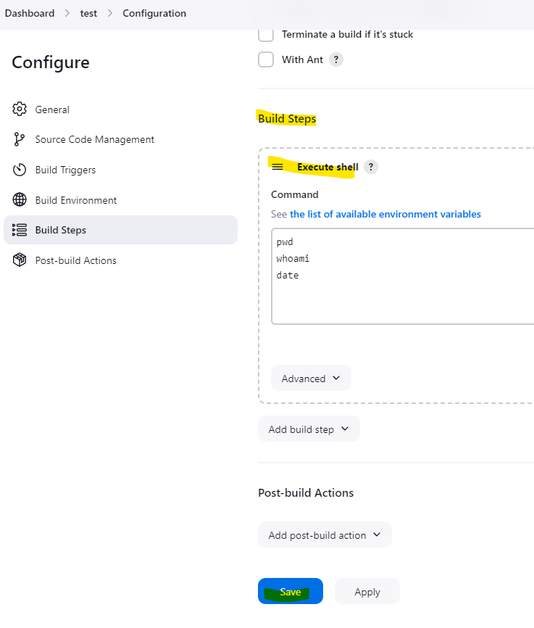

* Once we run Build Now, it should us the build number and console output should confirm that it ran on the worker node.

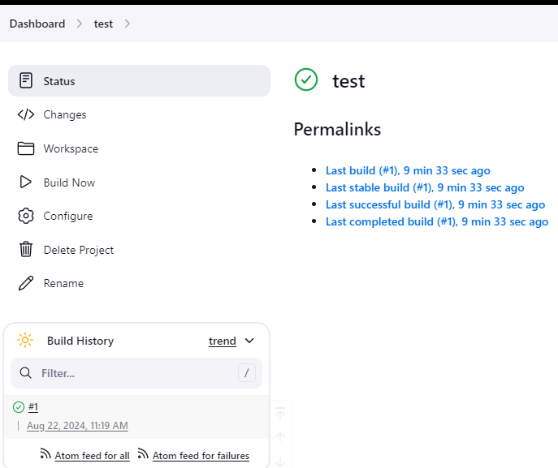

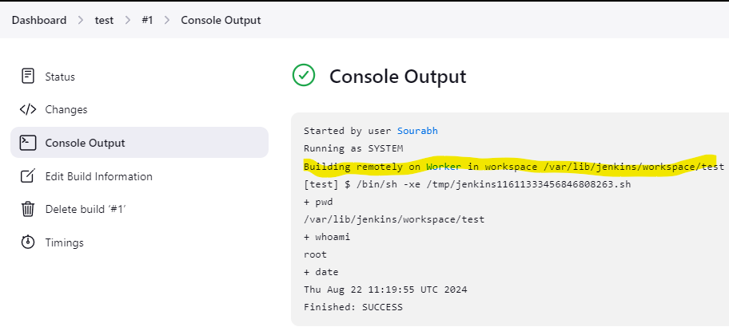

* The console output confirms that the build ran on Worker Node.